SECTION 1 – MAJOR APPLICATIONS

Item No. | 1/01
Address: | 395 KENTON LANE, HARROW
Reference: | P/2652/12
Description | REDEVELOPMENT TO PROVIDE 8 FLATS AND 370 SQM OF RETAIL FLOOR SPACE (A1) IN A FOUR STOREY BUILDING WITH ALTERATIONS TO AN EXISTING CROSS OVER AND THE FORMATION OF A NEW CROSS OVER; DEMOLITION OF EXISTING BUILDING (MOT SERVICE CENTRE).
Ward | KENTON WEST
Applicant: | LAMBERT LIMITED
Agent: | PATRICK LEWIS ARCHITECTS LTD
Case Officer: | CALLUM SAYERS
Expiry Date: | 29 NOVEMBER 2012
RECOMMENDATION
GRANT planning permission for the development described in the application form and submitted plans, subject to conditions:
REASON
The development would contribute to the delivery of housing within the borough. The redevelopment of the site would result in a modern, contemporary design that responds appropriately to the local context, and would provide adequate living conditions for future occupiers of the development. The layout and orientation of the building and separation distance to neighbouring properties is considered to be satisfactory to protect the amenity of the neighbouring occupiers and the development would not result in any adverse impacts upon highway safety or convenience.

The decision to GRANT planning permission has been taken having regard to National Planning Policy, the policies and proposals in The London Plan 2011, the Harrow Core Strategy 2012 and the saved policies of Harrow Unitary Development Plan 2004, and to all relevant material considerations, to meet the Vision of the Council in promoting a diverse community, which is celebrated and valued and create better cohesion, as detailed in Harrow’s Sustainable Community Strategy [Apr 09], and any comments received in response to publicity and consultation.
INFORMATION:
This application is being reported to committee as the proposal constitutes development of more than 2 dwellinghouses and therefore falls outside of Categories 1(b) and 1(d) of the Scheme of Delegation.
Statutory Return Type: Medium Scale Development
Council Interest: None
Site Area: 0.0898ha
Gross Proposed Internal Floorspace: 1064.93sqm
GLA Community Infrastructure (CIL) Contribution: £38,734.50 (based on an a floor area of 1106.70 sqm)
Site Description
- The application site is located to the south west of Kenton Lane close to Belmont Circle.
- Kenton Lane is classified as a distributor road, and the application property falls within a designated local centre.
- The site currently comprises an existing single structure with a relatively large forecourt used as a MOT Service Centre (Sui Generis). The business however, has not been trading since October 2011 as a result of fire damage.
- The existing site has two vehicle crossovers that provide access onto Kenton Lane.
- Located to the north east of the site on the opposite side of Kenton Lane is a small Tesco Metro supermarket, which has a number of commercial units to the north of it. Further north and the corner with the Belmont Circle Roundabout is an Esso Gas Station. To the south of the Tesco is a break in the building line, where an accessway cuts between the Tesco and a terrace block of flats.
- Located to the north-west and on the same side of Kenton Lane is a parade of shops known as Warwick Parade with flats located above. This parade of shops is designated as Local Centre. To the south east is the Belmont Community Hall and public car park.
- To the south-west behind the site is a service road which runs from Kenmore Avenue to Kingshill Drive. Beyond this are some garages and then the rear elevations of a number of residential properties facing onto Elgin Avenue.

Proposal Details
- The application proposes to demolish the existing MOT Service Centre on site and replace it with a four storey building which would comprise A1 commercial use on the ground floor level and three floors above comprising of eight residential units.
- The proposed building would have an ‘L’ shaped footprint of 460.6m2 within the existing 898m² site. The front elevation of the proposed building will continue on from the front elevation of the existing shopping parade on Kenton Lane. This will continue across the front of the site until the accessway to the site from Kenton Lane on the southern boundary.
- On the northern elevation, the proposed building at single storey would extend the full depth of the site, and have a width of 12.42m and a height of 4.0m. This element would effectively replace an existing single storey structure that projects to the rear boundary of the property currently.
- The proposed building would have a width fronting Kenton Lane of 23.34m, with the main element containing the residential use having a depth of 12.09m.
- The proposed building would have a height of 10.4m to the top of the second floor, which forms the main bulk of the building. The building would have a maximum height of 12.24m at the highest point, which is the third floor roof element that is proposed to be set back from the front elevation facing onto Kenton Lane by 2m and 0.6m from the rear elevation.
- The proposed building would be constructed at ground, first and second floor from brick, with Roman Red Blend by Ibstick being selected. The roof element is proposed to be finished in fibre cement cladding panels.
- The ground floor level commercial unit of 329.13sq.m would be used as a Class A1 retail unit. No advertising has been proposed for the A1 unit. The proposed A1 unit would be accessed via Kenton Lane, and its refuse collection would be located at the rear of the single storey rear projection off the service lane.
- No on-site car parking is proposed for the A1 use class on the ground floor.
- The residential development would comprise of eight residential units over three floors, and would provide 5 x 2 bedroom flats and 3x 1 flats. The flats would be accessed via a single door near the southern end of the front elevation facing onto Kenton Lane.
- At first floor level it is proposed to have three flats, this layout is replicated above on the second floor. The proposed flats are accessed via a central core, and it is proposed to have both a staircase and lift facility.
- At third floor level it is proposed to have two flats, being 1 x two bedroom and 1 x one bedroom.
- Each of the proposed flats have provided for amenity space by way of private balconies that are recessed within the front elevation.
- It is proposed to provide eight on-site car parking spaces for the flats, one of which would be designated a disabled space. The car park would be accessed via the existing cross over, which is proposed to be retained and made good. Secured cycle provision for eight bicycles has been provided at ground floor level.
- Separate secure waste and recycling facilities have been provided at ground floor level for both the A1 commercial unit and the residential units.
- A 21.60m² raised landscaping and integrated watering system platform is proposed to be installed in north-western corner of the car parking area.

Relevant History
P/1011/12
Demolition of existing building (MOT Service Centre); Redevelopment to provide 8 flats and 370sqm of retail floor space (class A1) at ground floor level in a proposed four-storey building; alterations to existing cross-over and provision of a new cross over.
Decision – Withdrawn

PRE-APPLICATION
- HA\2012\ENQ\00001

Applicant Submission Documents
- Proposed Plans
- 3-Dimensionsal Images.
- Design and Access Statement (including Statement of Community Involvement)
Consultations
Drainage Team
No objections subject to conditions

Traffic and Parking
No Objection.
Advertisement:
N/A

Notifications
Sent: 42
Replies: 1
Expiry: 02/11/2012

Re-Notifications (14 Day consultation)
Sent: 42
Replies: 0
Expiry: 02/11/2012

Neighbours Consulted:
205 Kingshill Drive, Kenton, Harrow, HA3 8QT
207 Kingshill Drive, Kenton, Harrow, HA3 8QT

397 Kenton Lane, Harrow, HA3 8RZ
397a Kenton Lane, Harrow, HA3 8RZ
397b Kenton Lane, Harrow, HA3 8RZ
399 Kenton Lane, Harrow, HA3 8RZ
399a Kenton Lane, Harrow, HA3 8RZ
399b Kenton Lane, Harrow, HA3 8RZ
401 Kenton Lane, Harrow, HA3 8RZ
401a Kenton Lane, Harrow, HA3 8RZ
406 Kenton Lane, Harrow, HA3 8RQ
408 Kenton Lane, Harrow, HA3 8RQ
410 Kenton Lane, Harrow, HA3 8RQ
412 Kenton Lane, Harrow, HA3 8RQ
Flats 380 – 386 Kenton Lane, Harrow, HA3 8RG (Even)
Flats 388 – 394 Kenton Lane, Harrow, HA3 8RG (Even)
Flats 396 – 402 Kenton Lane, Harrow, HA3 8RG (Even)

114 Elgin Avenue, Harrow, HA3 8QJ
116 Elgin Avenue, Harrow, HA3 8QJ
118 Elgin Avenue, Harrow, HA3 8QJ
120 Elgin Avenue, Harrow, HA3 8QJ
122 Elgin Avenue, Harrow, HA3 8QJ
124 Elgin Avenue, Harrow, HA3 8QJ
126 Elgin Avenue, Harrow, HA3 8QJ
128 Elgin Avenue, Harrow, HA3 8QJ
Garages Rear of 118 Elgin Avenue, Harrow, HA3 8QJ

Tesco Store Ltd, 404 Kenton Lane, JA3 8RQ
Public Convenience Adjacent to 404, Kenton Lane, Harrow.
Belmont Assembly Hall, Kenton Lane, Harrow, HA3 8RZ

Summary of Responses:
- The proposed development would exacerbate the car parking issue that is already present within the neighbouring residential streets.

APPRAISAL
The Government has issued a Draft National Planning Policy Framework (NPPF) that consolidates national planning policy. This has been considered in relation to this application, but it carries limited weight at this stage of the consultation process as it is in draft form and subject to change. Existing national planning policy remains and carries substantial weight and the NPPF does not propose any change in existing national policy relative to the issues of this application.

Section 38(6) of the Planning and Compulsory Purchase Act 2004 requires that:

‘If regard is to be had to the Development Plan for the purpose of any determination to be made under the Planning Acts, the determination must be made in accordance with the Plan unless material considerations indicate otherwise.’

In this instance, the Development Plan comprises The London Plan 2011, the Harrow Core Strategy 2012 and the saved policies of Harrow’s Unitary Development Plan 2004 [Saved by a Direction of the Secretary of State pursuant to paragraph 1(3) of Schedule 8 of the Planning and Compulsory Purchase Act 2004].

While this application has been principally considered against the saved policies in the Harrow Unitary Development Plan (2004) some regard has also been had to relevant policies in the Development Management Policies DPD (Pre-submission Draft) which forms a part of the emerging Local Development Framework for the Borough and will eventually replace the Harrow Unitary Development Plan (2004) when adopted.

The document has been subject to two rounds of consultation; between 13 May 2011 and 24 June 2011 on the Council’s Preferred Options Development Management Policies, and between 27 July 2012 and 7 September 2012 on the Pre-submission Draft document. The DPD has now been sent to the Secretary of State for Examination in Public which is expected to be held in January 2013. Before this, a 4 week consultation was held between 11 October 2012 to 8 November 2012 on the Council's Proposed Minor Modifications to the DPD as a result of responses received to the Pre-submission Consultation.
MAIN CONSIDERATIONS
- Principle of Development and Land Uses
- Housing Density and Unit Mix
- Design, Character and Appearance of the Area
- Layout and Amenity
- Traffic, Safety and Parking
- Accessibility
- Development and Flood Risk
- Sustainability
- Environmental Impact Assessment
- Statement of Community Involvement
- S17 Crime & Disorder Act
- Consultation Responses
- Principle of Development and Land Use
The National Planning Policy Framework (NPPF) sets out a presumption in favour of “sustainable development”. The NPPF defines “sustainable development” as meeting the needs of the present without compromising the ability of future generations to meet their own needs. The NPPF sets the three tenets of sustainable development for planning to be; to play an economic, social and environmental role. The NPPF, following the deletion of the Planning Policy Statements and Guidance Notes, continues to advocate that new development should firstly be directly towards previously developed land, recognising that “sustainable development” should make use of these resources first. The adopted Harrow Core Strategy 2012 sets out the spatial vision for the borough and along with the London Plan, identifies the Belmont and Kenton area as being deficient in housing quantum. Specifically Core Policy CS 10B states that a net contribution to housing supply will be sought as part of mixed use or conversion or redevelopment of sites within Kenton district centre and Belmont Circle local centre.

The application site was used as a MOT Service Centre. However, it has been vacant since October 2011. The site constitutes previously developed land in a local centre and the application seeks to redevelop the site.

The retail use on the ground floor would provide an active frontage in the ground floor and would therefore have a positive impact on the vitality and viability of the area. It is considered that the retail A1 use unit would provide a more appropriate land use within the local centre than the vacant and fire damaged MOT Service Centre.

The redevelopment of the site, is therefore acceptable in principle and it is considered that the proposed land uses, i.e. is appropriate in this location.
2) Housing Density and Unit Mix
London Plan policy 3.8 and Harrow Unitary Development Plan (2004) saved policy H7 require new development to provide a range of housing choices, in terms of the mix of housing sizes and types, taking account of the housing requirements of different groups. London Plan 3.4 sets out a range of densities for new residential development.

The proposed flats are meet the minimum Gross Internal Floor Area (GIA), which is discussed later within this document. Each of the rooms proposed provide a satisfactory level of circulation space and all have functional layouts that would allow for satisfactory arrangement for household equipment. Furthermore, each of the flats would provide ample access to natural light, and are considered to provide a good standard of living conditions for future occupiers.

In the context of the design and layout of the development and other site constraints, it is considered that such a density is appropriate in this location.

Unit Mix
The London Plan policy 3.9 and Harrow Unitary Development Plan (2004) saved policy H7 require new development to provide a range of housing choices, in terms of the mix of housing sizes and types, taking account of the housing requirements of different groups.

The development provides a mix of, one-bed (both wheelchair accessible), two-bed (three and four bed spaces) units. For a scheme of this scale and in a local centre location which is likely to be attractive to small family or professionals, it is considered that the units would be appropriate and would accord with development plan policies.
3) Design, Character and Appearance of the Area
Good design lies at the heart of National Planning Policy Framework. London Plan policies 7.4.B, 7.5.B and 7.6.B and saved policy D4 of UDP set out a number of design objectives that new developments should seek to achieve, with the underlying objective of requiring new development to be of high quality design. Policy 7.4.B and saved policy D4 of the UDP pay particular reference to design being correct in its context and respecting the public and local realm. Policy CS1.B of the adopted Core Strategy requires all new development to respond positively to local context in terms of design, siting, density and spacing and reinforce the positive attributes of local distinctiveness.

Scale and Siting
It is noted from the site visit, that there is no uniformity in the scale within the immediate area, and the proposed building would continue in this vein. The existing parade is characterised by buildings being sited to the front of their respective properties abutting the wide public footpath, with single storey rear projections extending to the service road to the rear of the parade.

The proposed building would be a marked difference in the current building line, which sees an inactive frontage of the MOT service centre set back from the front boundary of the property where it abuts pedestrian footpath on Kenton Lane. The proposed building will bring the frontage of the property almost in line with the existing parade of shops located to the north of the application site.

It is proposed to step the proposed building back marginally from the front elevation of the existing parade, which will provide a visual break between the two buildings blocks. This setback would result in a subservient gesture resulting in the proposed building to be setback behind the existing parade, allowing it to remain as the prominent feature within the street scene. The setback of the third floor element, further assists in limiting the scale and bulk of the building, and again draws from the similar set back roof design queue found on the existing shopping parade.

The proposed building would be of a similar scale and bulk as the adjoining parade when viewed from Kenton Lane. The height of the proposed building at second floor roof level, would be considered to be the height of the main bulk of the adjoining parade, and the proposed building would be only marginally higher at this point to where it abuts the adjoining parade. Furthermore the third floor which is located within the recessed roof element would match the height of the adjoining parade to the north.

Located to the south is the Belmont Community Hall, which is a single storey dual pitch structure running alongside Kenton Lane. Whilst it is acknowledged that there is a significant height difference between the proposed building and the Community Hall, there is a satisfactory distance located between them. Located between the northern flank elevation of Community Hall and the boundary treatment with the proposal site, is a vehicle access way which provides access to the rear of the Community Hall. On the application site, it is proposed to have the building set off the southern boundary to allow a vehicle access way to service the proposed car parking spaces to the rear of the site. The space between the two buildings (minimum of 8.5m) would ensure that there is sufficient breathing space between the two buildings, and as such the proposed building would not appear as a dominating feature over the Community Hall building.

Design and Appearance
Paragraph 60 of the NPPF encourages local planning authorities to adopt policies which do not stifle innovation, originality or initiative. The encouragement for innovative design is supported by saved UDP policy D4 which suggests in supporting paragraph 4.10 that new buildings should set standards for future development, not necessarily mimic what already exists.

The proposed development would result in three floors of traditional brick built building which would marry up generally with the height of the adjoining parade to the north. The set back of 0.15m would provide an adequate separation to allow shadow to be thrown to show a visual crease between the proposed development and the adjoining parade.

The proposed front elevation at ground floor would be mainly glazed to provide active frontages to the proposed A1 retail use. It is considered that the addition of another active shop in this area of Kenton Lane would enhance the vitality into the local centre and improve the appearance of what is currently an inactive and un-neighbourly frontage, which detracts from the existing street scene.

At upper floor levels, the front elevation would provide interest in the streetscene by way of two vertical breaks within the front elevation which effectively sees the elevation split into three different segments. Furthermore, the juxtaposition of the glazing in the front elevation with both the recessed balconies and windows would ensure that that the front elevation would provide a level of interest to the street. In addition the applicant has stated within their Design and Access Statement that the proposed brickwork would incorporate a weaving appearance on all elevations, which would assist in a high level of design that would contribute to the existing streetscene.

The proposed southern elevation is highly visible within the Kenton Lane streetscene, and would replace a bleak, uninteresting elevation currently viewed on the southern end of the existing shopping parade. Large windows introduced into the southern flank elevation extend from floor to ceiling and assist in breaking up the elevation as well as providing ample access to light for future occupiers. As mentioned previously the weaving of the brickwork further adds a high level of design into the development and ensures an interesting elevation when viewed from the public realm.

The roof element will be visually more contemporary than the remainder of the building, as a result of the fibre cement panes which are set back from the front and rear elevation. The contemporary nature of the materials forming the roof feature would not be at odds with the proposed brick work proposed. On the southern elevation the roof profile would be viewed as a continuation of the flank elevation, as this elevation would form a parapet with the roof sitting in behind. The proposed contemporary finish to the roof element would provide a contrast to that of the adjoining terrace, however it is considered with its appropriate set back, suitable colour tone and use of windows to break up the bulk, would ensure that it is not an overbearing element within the roof profile of either the proposed development or the adjoining parade to the north. In addition the proposed development would vastly improve the appearance of the existing southern elevation of the existing parade, which offers little in terms of interest or quality design.

Landscaping and the Public Realm
It is proposed to provide a 4.65m by 4.75m raised platform in the rear of the property in the propose car parking area, which would provide a landscaped area and also incorporate an integrated water system. Details of which will be secured by way of a condition.

The front of the property currently has two vehicle crossovers, which are noted as being in poor condition. It is proposed to reinstate the northern cross-over back to public footpath, and the applicant has stated that this will include the reinstatement of the cross over and tying the footpath in with the existing footpath to the north. The existing cross over to the south is proposed to be utilised to provide access to the car parking spaces at the rear of the site. This crossover is also in poor repair, and it is proposed to make good this cross over to service the car park. It is considered that by reinstating the damaged and poor conditioned crossover to the north, and making good the existing southern crossover will improve the existing streetscene by providing a tidier appearance to the public realm.

To ensure appropriate soft and hard landscaping schemes are provided in these areas, conditions are attached requiring details of the species planting, landscape management plan and the hardsurfacing materials for the cross over and public footpath.

Refuse and Servicing
It is proposed to service the ground floor A1 retail unit via the service road to the rear of the site, where waste and recycling will also be located. The waste and recycling for the residential units would be stored in an internal secured bin store in the southern flank elevation of the proposed building. This would be located near to Kenton Lane and have a level access to the highway. Both refuse stores would be adequate for the purposes of the development and would ensure servicing arrangements would not be compromised and given that they are internal storage locations would not adversely affect the existing street scene of Kenton Lane. Exact details relating to the waste and recycling facilities will be secured by way of a conditions.

4) Layout and Amenity
Neighbouring Amenity

Located to the north of the site is the existing parade of shops, which are noted as having residential units above them. The footprint of the proposed development on the rear elevation is flush with the upper floors of this parade, which have habitable windows on the rear. The proposed upper floors (above ground floor) continue flush for a distance of 4.57m away from the adjoining terrace before projecting west toward the rear of the property by 4.39m, The proposed floor plans demonstrate that this rear projection would not project through the horizontal 45 degree line, which ensures that there would be no loss of light or outlook to the adjoining property/terrace.

The flats located in the upper floors of the parade of shops to the north do not appear to have rear amenity spaces. There would therefore be no loss of privacy or an unacceptable level of overlooking. The upper stories of the rear projection at the adjoining property to the north are noted as having flank windows facing the proposal site, these are noted as not being the sole source of light to the rooms to which they serve, as there are rear facing windows on this outrigger element. Given dual aspect of these rooms located in the outrigger, and the extension being 6.81m away, it is considered that there would not be an unacceptable loss of light to these rooms. Furthermore there are no flank windows proposed in the northern elevation of the outrigger element. It is considered that there would be no loss of privacy to the properties located to the north from future occupiers of the residential units.

Located to the west (rear) of the proposed development are residential properties that are facing away from the development, onto Elgin Avenue. The proposed development has provided an internal layout that results in most habitable rooms located to the front elevation overlooking Kenton Lane. Notwithstanding this there is still in excess of 21m between the rear elevation of the proposed development residential floors and the rear habitable windows of dwellings facing onto Elgin Avenue. The proposal would therefore not unacceptably impact their living conditions by way of any unacceptable loss of privacy, overlooking or perceived overlooking. In addition there are a row of garages fronting onto the rear service road between the proposed development and rear of properties facing onto Elgin Avenue that assist in screening the development from these properties.

The building opposite the side is used for commercial purposes only. These include a Tesco Metro on the ground floor, with other convenience stores and a restaurant to the north in the rest of the parade. Given this, it is considered there would not be any unreasonable harm to these properties.

The Belmont Community Hall to the south is set off from the proposed southern elevation by approximately 8.0m, as located between it and the development site are the accesses to both properties.

As such, it is considered that the proposed development would not adversely affect the amenities of any of the neighbouring occupiers, thereby according with policy 7.6.B of The London Plan 2011 and saved policies D4 and D5 of the Harrow Unitary Development Plan 2004.

Layout and Future Occupiers
New residential developments should detail how many bedspaces they propose to provide, and Table 3.3 of the London Plan sets out the minimum space standards to be meet for the respective accommodation. The table below compares the proposed bedspaces and gross internal floor area proposed against the minimum standards set by the London Plan.

 | No. of Bed Spaces | London Plan Requirement | Proposed Gross Floor Area
Flat 1 | 2 bed, 3 bed spaces | 61m² | 61m²
Flat 2 | I bed, 2 bed spaces | 50m² | 51m²
Flat 3 | 2 bed, 4 bed spaces | 70m² | 72m²
Flat 4 | 2 bed, 3 bed spaces | 61m² | 61m²
Flat 5 | I bed 2, bed spaces | 50m² | 51m²
Flat 6 | 2 bed, 4 bed spaces | 70m² | 72m²
Flat 7 | 1 bed, 2 spaces | 50m² | 64m²
Flat 8 | 2 bed, 2 bed spaces | 70m² | 84m²

The above table demonstrates that each of the proposed flats either meet or exceed the minimum gross internal floor area for their respective bedspaces. Furthermore the proposed layout of the units provide for regular shaped rooms with access to light and good circulation.

The proposed plans demonstrate that Flat 7 has a bedroom that is located directly above a single bedroom in flat 4, and Flat 8 has a kitchen/living/dining room that sits above a bedroom within flat 6 on the second floor. Ideally it is sought to ensure that rooms with the same or similar use be stacked vertically above each other, such as bedroom above bedroom, rather than living rooms above. This is to ensure that noise is not transmitted vertically and creates a noise nuisance for future occupiers.

The proposed development would, in the main, stack appropriately in a vertical fashion, with the exception of some of the units on the third floor of the building fronting Kenton Lane (issues arise in relation to just two of the units). Given the new build nature of development, it is considered that compliance with Building Regulations would adequately ensure that the amenities of future occupiers would not be prejudiced by such minor conflicts in vertical stacking terms.

Flats two and five are noted as both being wheelchair accessible, thereby ensuring that 25% of the development would be wheelchair compatible. Flats two and five are located on the first and second floor respectively, and could be accessed via a communal lift.

Noise
The proposed development would provide a high quality layout and design and care has been taken to ensure the privacy and amenities of all occupiers would not be compromised. Accordingly, it is considered that the proposed development would accord with policies 7.6.B and 7.15.B of The London Plan 2011 and saved policies EP25, D4 and D5 of the Harrow Unitary Development Plan 2004
5) Traffic, Safety and Parking
The development proposes eight car parking spaces (including an accessible space) and eight secure cycle spaces. The site has a very poor Public Transport Accessibility Level (PTAL) level of 1b. Given the low PTAL of the site, it is considered that the eight spaces are an appropriate level for the eight flats.

Any potential new parking demand is expected to be 'linked trip' based and therefore low given the existing attractions/destinations at Belmont Circle which already generate activity. There are two public car parks within convenient walking distance of the site which can accommodate any newly generated activity.

As part of the proposed development there would be the removal of the existing northern cross over, which will be reinstated to match the quality and appearance of the existing footpath. Te existing cross over to the south of the site is proposed to be made good and brought into sole use to service the on-site car park. The southern corner of the proposed building has been chamfered to follow the arc of the cross over to allow for increased visibility for vehicles exiting the site. This chamfer provides a satisfactory visibility splay and ensures pedestrian safety.

It is proposed to provide for eight bicycle spaces inside the communal ground floor access to the residential units. The proposed provision for bicycle spaces would be secured and have an acceptable quantum.

Indeed the existing parade is designated as a Local Centre within the adopted Core Strategy, which identifies such centres as being mainly convenience shops and walk to services for a local catchments.

Subject to safeguarding conditions, it is considered that the proposed development would accord with policies 6.2, 6.3.A/B/C and 6.13.C/D/E of The London Plan 2011 and saved policies T6 and T13 of the Harrow Unitary Development Plan 2004.
6) Accessibility
The applicant has indicated in the Design and Access Statement and the submitted plans that all residential units would be Lifetime Homes and two flats would be wheelchair homes. The development would thereby accord with London Plan policy 3.5 and 7.2.C, policy CS1.K of The Harrow Core Strategy 2012, saved UDP policies D4 and C16 and the adopted SPD: Accessible Homes 2010.

The applicant has not indicated if the retail unit would accord with Equality legislation standards. However this would be secured under Building Regulations legislation in any event. It is therefore considered unnecessary to attach conditions requiring the development to accord with accessibility standards as this would be secured under other legislation and a planning condition would introduce unnecessary duplication.
7) Development and Flood Risk
The site is not located within a flood zone. However, given the potential for the site to result in higher levels of water discharge into the surrounding drains which could have an impact on the capacity of the surrounding water network to cope with higher than normal levels of rainfall, the Council’s Drainage Team has commented on the application and recommended conditions to ensure that development does not increase flood risk on or near the site and would not result in unacceptable levels of surface water run-off. Subject to compliance with these conditions, the development would accord with National Planning Policy, The London Plan policy 5.12.B/C/D and saved policy EP12 of the UDP.
8) Sustainability
Policy 5.1 of The London Plan (2011) seeks to achieve an overall reduction in London’s carbon dioxide emissions of 60 per cent by 2025. Policy 5.2A/B of The London Plan (2011) sets out the ‘lean, clean, green’ approach to sustainability, which is expanded in London Plan policies 5.3A, 5.7B, 5.9B/C, 5.10C and 5.11A. Harrow Council has adopted a Supplementary Planning Document on Sustainable Building Design (adopted May 2009).

The applicant has stated that the proposal will meet Code Level 4 of the Sustainable homes as well as a 25% reduction in Carbon emissions. The applicant has requested that this matter be secured by way of a condition, which the Council consider as being a satisfactory mechanism and have been attached accordingly.
9) Statement of Community Involvement
The applicant has submitted information relating to pre-application discussions with local residents, which was undertaken in a public meeting on the 22nd September 2012 at the Belmont Community Hall. The applicant has stated minor amendments have been undertaken to the scheme in direct response to some of the issues raised at this public meeting. It is considered that the applicant has fulfilled their obligations as set out in the NPPF and Localism Act.
10) S17 Crime & Disorder Act 1998
Policies 7.3.B and 7.13.B of The London Plan and saved policy D4 of the UDP require all new developments to have regard to safety and the measures to reduce crime in the design of development proposal. The applicant has engaged in specific consultation with regard to Crime Prevention principles, and has demonstrated that the design and layout of the proposed development has taken into account these considerations. Accordingly, and subject to a condition to secure this, it is considered that the proposed development would not increase crime risk or safety in the locality, thereby according with policies 7.3.B and 7.13.B of The London Plan 2011 and saved policy D4 of the Harrow Unitary Development Plan 2004.
11) Consultation responses
Already limited parking within the area.
- The proposal would provide on-site parking for the residential units, which are in line with the requirements of the Unitary Development Plan.
- The limited size of the A1 ground floor unit would not result in a noticeable increase of vehicles to the area, and would be unlikely to exacerbate any car parking pressures given the two public car parks in the area.

CONCLUSION
The loss of the vacant Sui Generis MOT Service Centre use on the site would be offset by the provision of a high quality retail unit on the ground floor. The development would contribute to the delivery of housing within the borough. The redevelopment of the site would result in a modern, contemporary designed building that responds appropriately to the local context, and would provide adequate living conditions for future occupiers of the development. The layout and orientation of the building and separation distances to neighbouring properties are considered to be satisfactory to protect the amenity of the neighbouring occupiers and the development would not result in any adverse impacts upon highway safety or convenience.

For these reasons, weighing up the development plan policies and proposals, and other material considerations including comments received in response to notification and consultation as set out above, this application is recommended for grant.
CONDITIONS:
1 The development hereby permitted shall be begun before the expiration of three years from the date of this permission.
REASON: To comply with the provisions of Section 91 of the Town and Country Planning Act 1990.
2 Notwithstanding the details of materials shown on the approved drawings, the development hereby permitted shall not commence until samples of the materials to be used in the construction of all external surfaces noted below have been submitted to, and approved in writing by, the local planning authority:
a: the building
b: the ground surfacing
c: the boundary treatment.
The development shall be carried out in accordance with the approved details and shall thereafter be retained.
REASON: To ensure a satisfactory form of development and safeguard the appearance of the locality, thereby according with policies 7.4.B and 7.6.B of The London Plan 2011, policy CS1.B of the Harrow Core Strategy 2012 and saved policy D4 of the Harrow Unitary Development Plan 2004
3 Prior to the construction of the building hereby permitted on site, details of the landscape area in the rear car park shall be submitted to, and approved in writing by the Local Planning Authority. The details shall include:
a: Plant selection comprising predominately native species appropriate to and applicable for aspect and use to encourage biodiversity
b: An agreed mix of species to be planted within the first planting seasons as agreed in writing by the Local Planning Authority, following practical completion of the building works.
The development shall be carried out in accordance with the details approved, and shall thereafter be retained in that form, unless otherwise agreed in writing with the local planning authority.
REASON: To ensure that the green roof would have an acceptable appearance on the character and appearance of the locality in the longer term, thereby according with policies 5.3.B/C and 7.4.B of The London Plan 2011, policy CS1.B of The Harrow Core Strategy 2012 and saved policies D4 of the Harrow Unitary Development Plan 2004
4 All planting, seeding or turfing comprised in the approved details of landscaping plans shall be carried out in the first planting and seeding seasons following the occupation of the building(s), or the completion of the development, whichever is the sooner. Any existing or new trees or shrubs which, within a period of 5 years from the completion of the development, die, are removed, or become seriously damaged or diseased, shall be replaced in the next planting season, with others of a similar size and species, unless the local authority agrees any variation in writing.
REASON: To safeguard the appearance and character of the area, and to enhance the appearance of the development, thereby according with policy 7.4.B of The London Plan 2011, policy CS1.B of the Harrow Core Strategy 2012 and saved policies D4 and D9 of the Harrow Unitary Development Plan 2004
5 Prior to the construction of the building hereby approved on site, additional details of a strategy for the provision of communal facilities for television reception (eg. aerials, dishes and other such equipment) shall be submitted to and approved in writing by the Local Planning Authority. Such details shall include the specific size and location of all equipment. The approved details shall be implemented prior to the first occupation of the building and shall be retained thereafter. No other television reception equipment shall be introduced onto the walls or the roof of the building without the prior written approval of the Local Planning Authority.
REASON: In order to prevent the proliferation of individual television reception items on the building which would be harmful to the character and appearance of the building and the visual amenity of the area, thereby according with policy 7.4.B of The London Plan 2011 and saved policy D4 of the Harrow Unitary Development Plan 2004.
6 Notwithstanding the approved plans, no ventilation, extraction systems or associated ducting shall be introduced onto the exterior elevations of the building without the prior written permission of the Local Planning Authority.
REASON: To ensure an appropriate standard of development which provides a high quality appearance in the interests of the visual amenity of the area, thereby according with policy 7.6.B of The London Plan 2011 and saved policy D4 of the Harrow Unitary Development Plan 2004.
7 Prior to the construction of the building hereby approved on site, details of a scheme for external lighting to the site shall be submitted to an approved in writing by the Local Planning Authority. The development shall be carried out in accordance with the approved details and shall thereafter be retained.
REASON: To ensure that lighting within the site does not cause unacceptable nuisance to residents of the development, thereby according with saved policy D4 of the Harrow Unitary Development Plan 2004.
8 No demolition or site works in connection with the development hereby permitted shall commence until the boundary of the site is enclosed by a close boarded fence to a minimum height of 2 metres. Such fencing shall remain until works and clearance have been completed, and the development is ready for occupation.
REASON: In the interests of highway safety and the amenities of the neighbouring occupiers, thereby according with policies 6.13.C/D/E and 7.6.B of The London Plan 2011 and saved policies D4 and T13 of the Harrow Unitary Development Plan 2004
9 No plant or machinery, including that from fume extraction, ventilation and air conditioning, which may be required by reason of granting this permission, shall be installed within the building without the prior written approval of the local planning authority. Any approved plant or machinery shall be operated only in accordance with the approved details.
REASON: To ensure that the proposed development does not give rise to noise or odour nuisance to neighbouring residents, thereby according with saved policies EP25, R15 and D4 of the Harrow Unitary Development Plan 2004.
10 The retail use hereby permitted on the ground floor of the development shall only be open to customers within the following hours:
0700 and 2300hrs on Mondays to Sundays and Bank Holidays;
No deliveries shall take place outside of these hours.
REASON: To safeguard the neighbouring and future occupiers of the residential units on the site from undue levels of noise and disturbance, thereby according with policy 7.15.B of The London Plan 2011 and saved policies EP25 and D4 of the Harrow Unitary Development Plan 2004
11 No construction / works in connection with the proposed development shall be carried out before 0800hrs or after 1800hrs on weekdays and Saturdays or at any time on Sundays or Bank Holidays.
REASON: To safeguard the amenity of the neighbouring occupiers, thereby according with saved policy D4 of the Harrow Unitary Development Plan 2004
12 No development shall take place, including any works of demolition, until a Construction Method Statement has been submitted to, and approved in writing by, the local planning authority. The approved Statement shall be adhered to throughout the construction period. The Statement shall provide for:
- the parking of vehicles of site operatives and visitors
- loading and unloading of plant and materials
- storage of plant and materials used in constructing the development
- measures to control the emission of dust and dirt during construction
- a scheme for recycling/disposing of waste resulting from demolition and construction works
REASON: To ensure that the construction of the development does not unduly impact on the amenities of the existing occupiers of the properties on the site, thereby according with saved policies D4 and T13 of the Harrow Unitary Development Plan 2004
13 The development of any buildings hereby permitted shall not be commenced on site, until works for the disposal of surface water have been submitted to, and approved in writing by, the local planning authority. The development shall be completed in accordance with the details as approved and thereafter maintained.
REASON: To ensure that adequate drainage facilities are provided, reduce and mitigate the effects of flood risk accordance with the National Planning Policy Framework 2012, policy 5.12.B/C/D of The London Plan 2011 and saved policy EP12 of the Harrow Unitary Development Plan 2004
14 The development of any buildings hereby permitted shall not be commenced on site, until surface water attenuation and storage works have been submitted to, and approved in writing by the local planning authority. The development shall be completed in accordance with the details as approved and thereafter maintained.
REASON: To ensure that adequate drainage facilities are provided, reduce and mitigate the effects of flood risk accordance with the National Planning Policy Framework 2012, policy 5.12.B/C/D of The London Plan 2011 and saved policy EP12 of the Harrow Unitary Development Plan 2004
15 Within 3 months (or other such period agreed in writing by the Local Planning Authority) of the first occupation of the development hereby approved, a post construction assessment shall be undertaken for each phase demonstrating compliance with the approved Energy Report and BREEAM Assessment; which thereafter shall be submitted to the Local Planning Authority for written approval.
REASON: To ensure the delivery of a sustainable development in accordance with the National Planning Policy Framework 2012, policies 5.2.B/C/D/E of The London Plan 2011, saved policy D4 of the Harrow Unitary Development Plan 2004 and adopted Supplementary Planning Document – Sustainable Building Design 2009.
16 Notwithstanding the requirements of the Town and Country Planning (Control of Advertisements) (England) Regulations 2007, any future advertisement associated with the development/use on site, shall only be located within the designated zones for signage as demonstrated on approved plan no. PLA142:PL93 (Rev A).
REASON: For the interest of public safety and amenity.
17 The development hereby permitted shall be carried out and completed in accordance with the following approved plans and documents:
PLA142: EX01, PLA142: EX02, PLA142: EX03, PLA142: EX04, PLA142: PL81 (Rev B), PLA142: PL82 (Rev B), PLA142: PL83 (Rev A), PLAA142, PL84, PLA142: PL85 (Rev B), PLA142: PL86 (Rev A), PLA142: PL87 (Rev A); PLA142: PL88, PLA142: PL89, PLA142: PL92, PLA142: PL93 Rev A), Design and Access Statement.
REASON: For the avoidance of doubt and in the interests of proper planning.
INFORMATIVES:
1 INFORMATIVE:
SUMMARY OF REASONS FOR GRANT OF PLANNING PERMISSION:
The development would contribute to the delivery of housing within the borough. The redevelopment of the site would result in a modern, contemporary design that responds appropriately to the local context, and would provide adequate living conditions for future occupiers of the development. The layout and orientation of the building and separation distance to neighbouring properties is considered to be satisfactory to protect the amenity of the neighbouring occupiers and the development would not result in any adverse impacts upon highway safety or convenience.

The decision to GRANT planning permission has been taken having regard to National Planning Policy, the policies and proposals in The London Plan 2011, the Harrow Core Strategy 2012 and the saved policies of Harrow’s Unitary Development Plan 2004, and to all relevant material considerations, to meet the Vision of the Council in promoting a diverse community, which is celebrated and valued and create better cohesion, as detailed in Harrow’s Sustainable Community Strategy [Apr 09], and any comments received in response to publicity and consultation.

National Planning Policy
National Planning Policy Framework 2012

The London Plan [2011]:
3.1.B – Ensuring Equal Life Chances for All
3.3 – Increasing Housing Supply
3.4 – Optimising Housing Potential
3.5 – Quality and Design and Housing Development
3.8.B – Housing Choice
3.9 – Mixed and Balanced Communities
5.2.A/B/C/D/E – Minimizing Carbon Dioxide Emissions
5.3.B/C – Sustainable Design and Construction
5.7.B – Renewable Energy
5.9.B/C – Overheating and cooling
5.12.B/C/D – Flood Risk Management
5.15.B/C – Water Use and Supplies
6.3.A/B/C – Assessing the Effects of development on transport capacity
6.5 – Funding Crossrail and other strategically important transport infrastructure
6.9 – Cycling
6.10 – Walking
6.12.B – Road Network Capacity
6.13.C/D – Parking
7.1.B/C/D/E – Building London’s Neighbourhoods and Communities
7.2.C – An Inclusive Environment
7.3.B – Designing out Crime
7.4.B – Local Character
7.5.B – Public Realm
7.6.B – Architecture
7.13.B – Safety, Security and Resilience to emergency
7.15.B – Reducing Noise and Enhancing Soundscapes

The Harrow Core Strategy 2012
CS1 – Overarching Policy
CS10 – Kenton & Belmont

Saved Policies of the London Borough of Harrow Unitary Development Plan [2004]:
EP12 – Control of Surface Water Run-Off
EP25 – Noise
EM15 – Land and Buildings in Business, Industrial and Warehousing Use Outside Designated Areas
D4 – The Standard of Design and Layout
D5 – New Residential Development – Amenity Space and Privacy
C16 – Access to Buildings and Public Spaces
T6 – The Transport Impact of Development Proposals
T13 – Parking Standards
H7 – Dwelling Mix

Adopted Supplementary Planning Documents
Supplementary Planning Document: Access for All 2006
Supplementary Planning Document: Accessible Homes 2010
Supplementary Planning Document: Sustainable Building Design 2009.
Supplementary Planning Document: Residential Design Guide 2010.

Emerging Development Plan Document: Development Management Policy 1.

2 Please be advised that approval of this application by Harrow Council will attract a liability payment of £38,734.50 of Community Infrastructure Levy. This charge has been levied under Greater London Authority CIL charging schedule and s211 of the Planning Act 2008. The charge has been calculated on the proposed net increase in floorspace.

Harrow Council as CIL collecting authority on commencement of development will be collecting the Mayoral Community Infrastructure Levy (CIL).

Your proposal is subject to a CIL Liability Notice indicating a levy of £38,734.50 for the application, based on the levy rate for Harrow of £35/sqm and the calculated net additional floorspace of 1106.70 sq.m

You are advised to visit the planning portal website where you can download the appropriate document templates.
http://www.planningportal.gov.uk/planning/applications/howtoapply/whattosubmit/cil

3 CONSIDERATE CONTRACTOR CODE OF PRACTICE
The applicant's attention is drawn to the requirements in the attached Considerate Contractor Code of Practice, in the interests of minimising any adverse effects arising from building operations, and in particular the limitations on hours of working.
4 PARTY WALL ACT:
The Party Wall etc. Act 1996 requires a building owner to notify and obtain formal agreement from adjoining owner(s) where the building owner intends to carry out building work which involves:
1. work on an existing wall shared with another property;
2. building on the boundary with a neighbouring property;
3. excavating near a neighbouring building,
and that work falls within the scope of the Act.
Procedures under this Act are quite separate from the need for planning permission or building regulations approval.
“The Party Wall etc. Act 1996: Explanatory booklet” is available free of charge from:
Communities and Local Government Publications, PO Box 236, Wetherby, LS23 7NB
Please quote Product code: 02 BR 00862 when ordering
Also available for download from the CLG website:
http://www.communities.gov.uk/documents/planningandbuilding/pdf/133214.pdf
Tel: 0870 1226 236 Fax: 0870 1226 237
Textphone: 0870 1207 405
E-mail: communities@twoten.com
5 COMPLIANCE WITH PLANNING CONDITIONS
IMPORTANT: Compliance With Planning Conditions Requiring Submission and Approval of Details Before Development Commences
- You will be in breach of planning permission if you start development without complying with a condition requiring you to do something before you start. For example, that a scheme or details of the development must first be approved by the Local Planning Authority.
- Carrying out works in breach of such a condition will not satisfy the requirement to commence the development within the time permitted.
- Beginning development in breach of a planning condition will invalidate your planning permission.
- If you require confirmation as to whether the works you have carried out are acceptable, then you should apply to the Local Planning Authority for a certificate of lawfulness.
6 CONSTRUCTION METHODS
The development hereby approved may be subject to the Construction (Design and Management) Regulations 1994 which govern health and safety through all stages of a construction project. The Regulations require clients (i.e. those, including developers, who commission projects) to appoint a planning supervisor and principal contractor who are competent and adequately resourced to carry out their health and safety responsibilities. Clients have further obligations. Your designer will tell you about these and your planning supervisor can assist you in fulfilling them. Further information is available from the Health and Safety Executive Infoline on 0541 545500.
(Please note that any reference in this informative to "planning supervisor" has no connection with any Planning Officers within Harrow's Planning Services or with the Town and Country Planning Act 1990.)
7 INFORMATIVE:
The applicant is reminded of the duties set out in the Equalities Act 2010 with regard to employment and service provision. An employer’s duty to make reasonable adjustment is owed to an individual employee or job applicant. However, the responsibility of service providers is to disabled people at large, and the duty is anticipatory. Failure to take reasonable steps at this stage to facilitate access will therefore count against the service provider if / when challenged by a disabled person from October 2004. The applicant is therefore advised to take full advantage of the opportunity that this application offers to improve the accessibility of the premises to people with mobility and sensory impairments.
Plan Nos: PLA142: EX01, PLA142: EX02, PLA142: EX03, PLA142: EX04, PLA142: PL81 (Rev B), PLA142: PL82 (Rev B), PLA142: PL83 (Rev A), PLAA142, PL84, PLA142: PL85 (Rev B), PLA142: PL86 (Rev A), PLA142: PL87 (Rev A); PLA142: PL88, PLA142: PL89, PLA142: PL92, PLA142: PL93 (Rev A), Design and Access Statement.

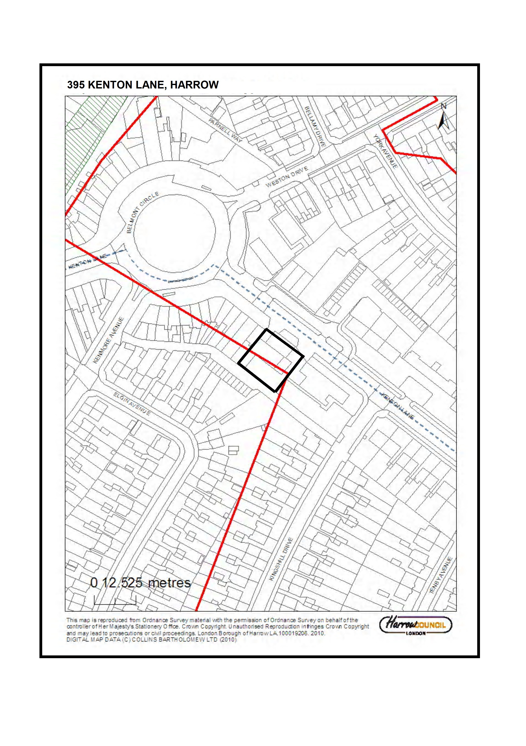

SECTION 2 - OTHER APPLICATIONS RECOMMENDED FOR GRANT

Item No. |  |  |  | 2/01
Address: |  |  |  | BENTLEY PRIORY, THE COMMON, STANMORE
Reference: |  |  |  | P/2322/12
Description |  |  |  | AMENDMENTS TO PHASE 5 OF APPROVED DEVELOPMENT (REFS P/1452/08 AND P/1726/11) TO ALTER THE LAYOUT, SITING, FOOTPRINT AND DESIGN OF THE 7 DETACHED DWELLINGHOUSES AND GARAGES; ASSOCIATED LANDSCAPING, ACCESS AND PARKING
Ward: |  |  |  | STANMORE PARK
Applicant: |  |  |  | MR NEIL COTTRELL (BANNER HOMES)
Case Officer: |  |  |  | NICHOLAS RAY
Expiry Date: |  |  |  | 18-OCT-12
RECOMMENDATION
GRANT planning permission for the development described in the application, subject to conditions.
REASON
The proposal to amend the approved development constitutes appropriate redevelopment of a previously developed site in the Green Belt. The amendments proposed would not be detrimental the openness of the site or the special interest of the listed building and historic park. It is considered that the proposal complies with all relevant policies and the associated impacts that could arise from the development would be adequately ameliorated through the use of appropriate planning conditions. The development therefore does not have any significant visual, transport, amenity or other impact that would warrant refusal of planning permission. The development is therefore found to be consistent with the National Planning Policy Framework (2012), the policies and proposals in The London Plan (2011), the Harrow Core Strategy (2012), the policies of the Draft Development Management DPD (2012) and the saved policies of the Harrow Unitary Development Plan (2004) set out below, and all relevant material considerations as outlined in the application report.
National Planning Policy:
National Planning Policy Framework 2012 (NPPF)
The London Plan 2011:
3.5 – Quality and Design of Housing Developments
3.11 – Affordable Housing Targets
3.12 – Negotiating Affordable Housing on Individual Private Residential and Mixed Use Schemes
5.2 – Minimising Carbon Dioxide Emissions
5.3 – Sustainable Design and Construction
5.7 – Renewable Energy
6.9 – Cycling
6.13 – Parking
7.1 – Building London’s Neighbourhoods and Communities
7.2 – An Inclusive Environment
7.3 – Designing Out Crime
7.4 – Local Character
7.6 – Architecture
7.8 – Heritage Assets and Archaeology
7.16 – Green Belt
7.19 – Biodiversity and Access to Nature
7.21 – Trees and Woodlands
London Borough of Harrow Core Strategy 2012:
CS1 – Core Policy
CS7 – Stanmore and Harrow Weald
London Borough of Harrow Draft Development Management Policies 2012:
Policy 23 – Redevelopment of previously-developed sites within Green Belt and Metropolitan Open Land
London Borough of Harrow Unitary Development Plan 2004:
EP25 – Noise
EP26 – Habitat Creation and Enhancement
EP27 – Species Protection
EP31 – Areas of Special Character
EP35 – Major Developed Sites in the Green Belt
D4 – The Standard of Design and Layout
D5 – New Residential Development – Amenity Space and Privacy
D9 – Streetside Greenness and Forecourt Greenery
D10 – Trees and New Development
D11 – Statutorily Listed Buildings
D18 – Historic Parks and Gardens
T6 – The Transport Impact of Development Proposals
T13 – Parking Standards
C16 – Access to Building and Public Spaces
Supplementary Planning Document: Residential Design Guide (2010)
Supplementary Planning Document: Accessible Homes (2010)
Bentley Priory Supplementary Planning Document (2007)
MAIN CONSIDERATIONS AND POLICIES (National Policy, The London Plan 2011, Harrow Core Strategy 2012, Draft Development Management Policies DPD 2012 and saved policies of The London Borough of Harrow Unitary Development Plan 2004)
1) |  |  | Principle of the Development
2) |  |  | Design, Character and Appearance of the Green Belt, Historic Park and Garden and Area of Special Character
3) |  |  | Impact on the Setting of the Listed Building
4) |  |  | Residential Amenity
5) |  |  | Trees and New Development
6) |  |  | Traffic and Parking
7) |  |  | Affordable Housing
8) |  |  | Ecology and Biodiversity
9) |  |  | Sustainability
10) |  |  | Accessible Homes
11) |  |  | Amendments to Planning Conditions and S.106 Obligations
12) |  |  | S17 Crime & Disorder Act
13) |  |  | Consultation Responses
INFORMATION
This application is reported to Planning Committee as it proposes the construction of more than two new dwellinghouses and therefore falls outside Category 1(b) of the Scheme of Delegation.
Summary
Statutory Return Type: |  |  |  |  |  |  | (E)13. Minor Dwellings
Council Interest: |  |  |  |  |  |  | None.
Net Additional Floorspace: |  |  |  |  |  |  | 3,513sqm
GLA CIL Contribution (provisional): |  |  |  |  |  |  | £122,955
Site Description
- The site comprises part of the former RAF Bentley Priory complex, a major developed site in the Green Belt and a landmark feature in the Harrow Weald Ridge Area of Special Character.
- The application site is at the northernmost point of the complex and is formed of two areas of open land either side of the main access road.
- The western part of the site is L-shaped and is bound to the north by the residential property Heriots Wood and by Common Road, to the west by The Common and to the south by the residential property The Cedar House.
- The eastern part of the site is bound to the east by the residential properties at Cedars Lodge and The Cedars, whilst to the south is the rest of the Bentley Priory complex, currently in the process of being redeveloped.
- Bentley Priory has historic interest as the former home of the RAF Fighter Command centre and is also the location of a Grade II* listed building set within a Grade II listed historic park and garden, comprising a number of protected trees.
- The mansion building has both high architectural and historic significance, incorporating designs by Sir John Soane and Robert Smirke.
- The site lies between the urban areas of Stanmore in the south and Bushey Heath to the north. Development in the immediate vicinity of the site generally comprises detached dwellings set in a sylvan landscape.
- To the south of the site is Bentley Priory Open Space, a designated Site of Special Scientific Interest (SSSI).
- Operational use of the site ceased in May 2008 and planning permission and listed building consent were subsequently granted for a change of use from a defence establishment to provide a museum/education facility and 103 dwellinghouses with associated energy centre, car parking, landscaping and demolition of listed buildings (refs P/1452/08CFU and P/1453/08CFU).
- Planning permission was subsequently granted for amendments to this permission (excluding the mansion building) to add 4 dwellings (ref P/1726/11, granted 22nd December 2012) and a number of amendments have been also been made to the permission for the mansion building (refs P/1840/11, P/1841/11 and P/1842/11).
- The site as a whole is being developed by two separate developers and works have commenced on site pursuant to the above consents.
- City and Country Residential are carrying out the works to the Grade II* listed mansion house and surrounding land, whilst Barratt Homes North London are carrying out the new build works on the remaining site.
- However, the application site has now been sold to Banner Homes and this application is submitted by them for amendments to this part of the scheme.
Proposal Details (Amendments to Extant Permission)
- The extant planning permissions (P/1452/08CFU and P/1726/11) permit 7 detached dwellings on the application site, 3 on the western part and 4 on the eastern part.
- It is proposed to retain this overall quantum and general arrangement, but with minor alterations to the layout, siting, footprint and design of the dwellings as set out below:
Plot 1 (previously plot 2.2)
- Substitute house type with approved house type from plot 1.1, with amendments to footprint, siting and design.
- The footprint of the detached garage has been increased, the siting of the dwelling is forward of the approved position by 1.7 metres and the external appearance has been altered.
Plot 2 (previously plot 2.3)
- The footprint of the detached garage has been increased and the footprint and design of the dwelling has been amended.
Plot 3 (previously plot 2.4)
- The footprint of the detached garage has been increased to be a triple garage instead of a double, as well as being re-sited.
- The footprint of the dwelling has been increased, the siting angle of the building has been altered and the design of the dwelling has been amended.
Plot 4 (previously plot 2.5)
- The footprint of the dwelling has been increased, the siting angle of the building has been altered and the design of the dwelling has been amended.
Plot 5 (previously plot 1.3)
- The footprint of the dwelling and detached garage has been increased and the design of the dwelling has been amended.
Plot 6 (previously plot 1.2)
- Substitute house type with approved house type from plot 2.2, with amendments to footprint, siting and design.
- The footprint of the dwelling has been reduced, the siting angle of the building has been altered and the design of the dwelling has been amended.
Plot 7 (previously plot 1.1)
- Same house type (and the same as now proposed at Plot 1).
- The footprint of the detached garage has been increased, the footprint of the dwelling reduced and the external appearance has been altered.
General
- Each driveway would increase in size, but access points from the access road would be as approved.
- Plot boundaries would be as approved.
Relevant History

P/1452/08CFU & P/1453/08CFU

Change of use from defence establishment to provide a museum/education facility (D1 use class) 103 dwelling (C3 class) with associated car parking, ancillary service/accommodation, energy centre, works to landscape (including open space provision, boundary fencing and removal of trees) with improved means of access to the common, and including alterations and partial demolition of the mansion house, alterations and extension of building 7. Relocation of entrance to the walled garden and demolition of other listed buildings

Granted :16-SEP-10

P/1726/11

Change of use from defence establishment to provide 93 dwellings (C3 use class) with ancillary buildings, concierge building and entrance gates with associated car parking, works to landscape (including open space provision, boundary fencing and removal of trees) with improved means of access to the common and demolition of listed buildings (amendments to previous planning permission reference P/1452/08CFU dated 16/09/2010 comprising removal of energy centre, addition of single storey concierge/garage building and security gates, additional 4 dwellings, additional parking spaces, re-siting of refuse/cycle stores and alterations to elevations of dwellings) (application site excludes mansion house and associated areas, as shown within the green line on drawing no.5229/001g)

Granted : 22-DEC-11

P/1840/11

First floor extension to building 7 and conversion to 5 dwellinghouses; external alterations (amendments to planning permission P/1452/08CFU dated 16/09/2010 to provide 2 additional dwellinghouses, enlargement of first floor extension and amendments to external alterations)

Granted : 04-NOV-11

P/1841/11
Part demolition and conversion of building 267 to 7 flats; external alterations to fenestration and insertion of rooflights (amendments to planning permission P/1452/08CFU dated 16/09/2010 to retain the building instead of replacing the building with 3 new dwellinghouses)

Granted : 14-OCT-11

P/1842/11

Conversion of dining room block to 4 flats with basement parking; external alterations (amendments to planning permission P/1452/08CFU dated 16/09/2010 to provide 3 additional flats, addition of basement parking and amendments to external alterations)

Granted : 14-OCT-11

Pre-Application Discussion (ref HA\2012\ENQ\00177)
- The existing consents permit the construction of 7 dwellings in this area and the main consideration would therefore be the impact of the proposed amendments on the openness of this part of the site, having regard to approved design and layout.
- The proposed amendments to the footprint and floorspace of these dwellings seem, on the face of it, to be fairly minor in terms of the impact on openness. Some dwellings would increase in floorspace/footprint, whilst some would decrease. A full schedule of approved and proposed floorspace/footprint should be provided with any application.
- The most noticeable increase in size proposed would be the increase from double garage to triple garage at plot 2.4, which will require further consideration.
- Minor realignment of driveways is unlikely to give rise to concerns over openness.
- Refinements made to the design during the pre-application process would ensure that the original spirit and quality of the design is maintained.
- The proposed curved brick walls with piers and gates to front boundaries are considered acceptable in principle, provided these are set away from the access road.
- The provision of air source heat pumps in place of the approved ground source heat pumps could be an acceptable method to reduce carbon emissions, subject to acceptable impact on visual or residential amenity.
- No additional s.106 obligations are considered necessary.
Applicant Statements
- Archaeological Evaluation.
- Design and Access Statement.
- Landscape Specification.
- Tree Report.
- Ecological Assessment.
- Vector Design (Energy Strategy).
Consultations:
Greater London Authority: The proposal does not raise any new strategic planning issues and results in a net decrease in building footprint. The Council may proceed to determine the application without further reference to the GLA.
Highways Authority: There is no specific concern with regard to the proposed design changes to the 7 units. The only thing that I stress is the need to ensure that refuse requirements (in collection distance terms) are met to ensure (under the site management regime) that the wheeling distance under LBH's refuse code of practice is minimised with bins placed as close as possible to the main access road on collection days. All plots are affected by this but in particular plots 5, 6 and 7. Otherwise there is no further comment other than all the usual requirements such as cycle provisions etc be carried through from the previous permission.
Site Notice: 03-OCT-12
Expiry: 24-OCT-12
Advertisement (Harrow Obs/Harrow Times): 13-SEP-12
Expiry: 04-OCT-12
Notifications:
Sent: 48 |  |  |  |  | Replies: 0 |  |  | Expiry: 03-OCT-12
Addresses Consulted:
- 1-21 (incl) Alpine Walk;
- Heath Lodge, Tanglewood Lodge, Tanglewood Cottage, Longcote, Chestnut Cottage, Tanglewood Close;
- Peterborough & St Margarets High School, Woodside, Cedar House, 1 & 2 Birch Cottages, Myrtle Cottage, 1 & 2 Sussex Villas, 1-3 Hunton Cottages, Rosedale Cottage, Hollycroft, Heathend, Common Road;
- Broad Oaks, Heriots Wood, The Cedars, Cedars Lodge, 1 & 2 The Cottage, Heathfield Lodge, The Common;
- Kestrel Grove Nursing Home, Hive Road;
- Flats 1-29 Highfield, 125-135 (odd), High Road, Bushey Heath;
- 1-5 (incl), Fairseat Close, Bushey Heath;
Summary of Response:
None received.
APPRAISAL
1) Principle of the Development
Bentley Priory is a designated strategic previously developed site in the Green Belt in the Council’s UDP and in the Draft Development Management Policies DPD under Policy 23. A Supplementary Planning Document has also been prepared to guide the site’s redevelopment.

This application proposes minor amendments to the original consent, comprising alterations to the layout, siting, footprint and design of the previously approved 7 detached dwellinghouses and garages on this part of the site. The proposals would result in a reduction in built footprint, would not increase the height of the buildings and would not materially increase the scale of the approved dwellings (this is discussed in more detail in appraisal section 2, below). The revised proposals, in the context of the overall and continuing development of the site, would therefore still constitute appropriate redevelopment of a previously developed site in the Green Belt and would therefore accord with the National Planning Policy Framework (2012), Core Policy CS1(F), Draft DM Policy 23 and saved UDP policy EP35.

2) Design, Character and Appearance of the Green Belt, Historic Park and Garden and Area of Special Character
Openness
Proposals for Bentley Priory were previously assessed under Annex C of PPG2, relating to redevelopment of major developed sites in the Green Belt. PPG2 has now been replaced by the NPPF, which does not contain specific guidance that can be used to provide the principles behind the redevelopment of major developed sites. The relevant passage of the NPPF is paragraph 89, as follows:

‘A local planning authority should regard the construction of new buildings as inappropriate in Green Belt…. Exceptions to this are limited infilling or the partial or complete redevelopment of previously developed site (brownfield land), whether redundant or in continuing use (excluding temporary buildings, which would not have a greater impact on the openness of the Green Belt and the purpose of including land within it than the existing development’ [officers emphasis]

The key consideration is therefore whether the proposal would have a greater impact on the openness of the Green Belt. In this instance, there is very little existing built development in this area of the site. However, the existing consents, which are being built out by Barratt Homes and City and Country, permit the construction of 7 dwellings in this area and this is therefore a fall back position. The main consideration would therefore be the impact of the proposed amendments on the openness of this part of the site, having regard to the approved design and layout. The table below sets out the approved footprint as compared to the footprint now proposed:

 | Approved Footprint (sqm) | Proposed Footprint (sqm) | Difference
Plot 1 | 260 | 265 | +5
Plot 2 | 327 | 309 | -18
Plot 3 | 505 | 496 | -9
Plot 4 | 514 | 533 | +19
Plot 5 | 214 | 217 | +3
Plot 6 | 304 | 260 | +44
Plot 7 | 304 | 265 | -39
Total | 2,248 | 2,345 | -83

The above figures demonstrate that whilst some of the dwellings would increase in footprint, there would be an overall reduction in built footprint across this part of the site. This would benefit openness. Also, the height of the dwellings would not increase, which is supported. It is noted that the amended siting of some of the plots would have an impact on the appearance of the buildings, for example plot 1 would be more prominent as it would be sited forward of the approved location. However, plots 6 and 7 would be sited further away from the Common Road boundary than the approved arrangement. On balance the revised sitings are considered to be acceptable. It is also noted that the revised designs for some of the plots would result in additional scale as compared to approved. However, when considered across the context of the scheme, it is considered that the impact on openness would not have a greater impact on the openness of the Green Belt than the approved scheme. The layout of the dwellings would not be significantly altered and adequate space would be retained between buildings and individual plot boundaries.

Design, materials, landscaping and boundary treatments
It is noted that this site is particularly sensitive in terms of policy designations, being with the Harrow Weald Ridge Area of Special Character and a Historic Park and Garden. The approved designs in this part of the site are intended to emulate the sylvan, loose grain character of surrounding residential development on Tanglewood Close and Priory Drive. The approved arts and crafts designs reflect the prevailing character in this area and provide a contrast to the ‘Soanist’ classical designs that are approved on the rest of the site.

The revised layout maintains the loose grain character of the approved scheme and retains space between buildings consistent with the surrounding pattern of development. Amendments are proposed to the external appearance of the dwellings. Officers are satisfied that, in the case of each individual house type and in the context of the 7 dwellings as a group, the design approach would be consistent with the arts and crafts principles set out in the Bentley Priory SPD and the original Design and Access Statement.

The submitted plans show the proposed dwellings to be finished in white render, with off white mullions, black windows and grey roof tiles, and this is consistent with how the previously approved designs were conceived. However, the applicant has expressed an intention to use a dark red brick on some of the house types and has provided a sample for consideration. The principle of a brick finish is considered acceptable, although officers feel that the scheme could benefit from further discussions on the details of materials. A condition is therefore recommended requiring full samples of all external materials to be submitted and approved prior to commencement.

A Landscape Strategy has been submitted with the application, although this does not contain detailed landscape proposals, including hard surface materials. This part of the scheme would have been subject to a detailed landscaping scheme pursuant to condition, so it is considered appropriate to recommend a condition in this regard.

The site boundaries to Common Road and The Common would be particularly sensitive, as would the southern boundary of the application site with the rest of the Bentley Priory complex. It would also be necessary to seek details of front boundary treatments, given that front boundary walls and gates are proposed. A condition is therefore recommended requiring details of boundary treatments and it would be appropriate for these to tie in with the proposed landscaping.
Refuse storage
No details of refuse storage have been provide with this application and it is noted that the Council’s Highways Engineer has commented that it would be necessary to ensure that collection points are within appropriate distances to collection vehicles. A condition was included on the earlier permission in relation to details of refuse storage and access. It is therefore considered appropriate to recommend a similar condition in this instance.

In summary, subject to conditions recommended, it is considered that the revised proposal for these 7 dwellings would adequately maintain the openness of the Green Belt in this location in line with the requirements of National Planning Policy Framework (2012), Core Policy CS1(F), Draft DM Policy 23 and saved UDP policy EP35. The proposals would also achieve a high standard of design in this sensitive location, as required by the National Planning Policy Framework (2012), Core Policy CS1(B), London Plan policies 7.4, 7.6 and 7.8 and saved UDP policies EP31, D4 and D18.

3) Impact on the Setting of the Listed Building
The proposed amendments would not have a materially greater impact on the setting of the Grade II* listed mansion building than the approved scheme. Particular regard will be had to the proposed boundary treatments and landscaping to the southern boundary as part of an approval of details application for these elements. The proposal would therefore be acceptable in relation to the National Planning Policy Framework (2012), Core Policy CS1(D), London Plan policy 7.8 and saved UDP policy D11.

4) Residential Amenity
The proposed amendments would not have a materially greater impact on the amenities of neighbouring residents in terms of loss of light or outlook, or from overlooking. The proposed dwellings would provide acceptable living conditions for future occupiers in terms of compliance with internal space standards and the provision of external amenity space. The proposal would therefore comply with London Plan policy 7.6 and saved UDP policy D5.

5) Trees and New Development
The submitted tree report demonstrates that the proposed re-siting and other amendments to the proposed dwellings would not require any additional tree removal and would have a materially greater impact on protected trees on the site. The recommended landscaping condition requires details of tree protection measures to be submitted and approved prior to commencement of development and this would ensure that trees are protected during the course of construction. The proposal would therefore be consistent with London Plan policy 7.21 and saved UDP policy D10.

6) Traffic and Parking
The vehicle accesses have not changed as compared to the earlier approval and proposed parking arrangements have not materially altered. The Council’s Highways Engineer raises no objections, subject to details of refuse storage collection as discussed above. Secure cycle storage provision would be available within the detached garages and the proposal would therefore be acceptable in this regard.

7) Affordable Housing
The off-site affordable housing contribution has already been paid by Barratt Homes. There is no uplift in residential units proposed as part of this application, nor is there expected to be a significant uplift in residential sales values. It is therefore considered unnecessary to revisit the affordable housing contribution as part of this proposal.

8) Ecology and Biodiversity
It is noted that habitat surveys have already been carried out across the site pursuant to the earlier permissions. However, a revised Ecological Assessment has been submitted with this application, which sets out a list of recommendations. These include the provision of bird and bat boxes within the site and recommendations for clearance and management of vegetation. A condition is recommended requiring details of bird and bat habitats to be sited and approved prior to construction above damp proof course level. The proposal would therefore provide biodiversity improvements in line with the requirements of saved UDP policy EP26.

9) Sustainability
The proposal carries forward the passive measures proposed for these dwellings as part of the Energy Strategy for approved Barratt Homes revisions to the original scheme (ref P/1726/11). It was previously proposed to utilise ground source heat pumps (GSHP) as a renewable energy solution. However, the applicant now proposes to utilise air source heat pumps (ASHP) instead.

Details of the ASHP installations have not been provided. However, it is considered that this equipment could be provided in a discrete, screened location on the dwellings. It is not expected that the noise levels generated by this equipment would be detrimental to residential amenity, given the low density nature of the surroundings. Notwithstanding this, a condition is recommended requiring details of siting and appearance of these units, as well as the provision of a noise report demonstrating that the equipment would not increase background noise levels to an unacceptable degree.

Subject to the above condition, and a condition requiring compliance with Code for Sustainable Homes Level 4, the proposed approach is considered to be consistent with policies 5.2, 5.3 and 5.7 of The London Plan (2011).

10) Accessible Homes
The proposed dwellings would comply with all 16 points of the Lifetime Homes standards and would therefore be accessible and inclusive to all.

11) Amendments to Planning Conditions and S.106 Obligations
Other than those that have already been discharged by Barratt Homes, all relevant conditions attached to the earlier consents have been carried over to this recommendation, as discussed in the above appraisal sections,.

The majority of the s.106 obligations in relation to the earlier permissions and agreements have been satisfied and it is therefore considered unnecessary to enter into a new legal agreement or amend any of the obligations.

12) S17 Crime & Disorder Act
The proposed amendments to the scheme would not give rise to any additional concerns relating to secure by design considerations and the proposal is therefore considered to be acceptable in this regard.

13) Consultation Responses
None received.
CONCLUSION
In summary, the proposal to amend the approved scheme constitutes appropriate redevelopment of a previously developed site in the Green Belt. The amendments proposed would not be detrimental the openness of the site or the special interest of the listed building and historic park. It is considered that the proposal complies with all relevant policies and the associated impacts that could arise from the development would be adequately ameliorated through the use of appropriate planning conditions, as set out below. The development therefore does not have any significant visual, transport, amenity or other impact that would warrant refusal of planning permission
CONDITIONS
1 The development hereby permitted shall be begun before the expiration of three years from the date of this permission.
REASON: To comply with the provisions of Section 91 of the Town and Country Planning Act 1990.

2 The development hereby permitted shall be carried out in accordance with the following approved plans: 010744/Pln/100; 102; 103; 104; 105 Rev A; 106 Rev A; 107 Rev A; 108 Rev A; 109; 110; 111; 112; 113; 201; Design and Access Statement; Archaeological Evaluation; Landscape Specification; Tree Report; Ecological Assessment; Vector Design (Energy Strategy).
REASON: For the avoidance of doubt and in the interests of proper planning.

3 The development hereby permitted shall not commence until samples of the materials to be used in the construction of the external surfaces of
- the buildings; and
- the ground surfacing.
have been submitted to, and approved in writing by, the local planning authority. The development shall be carried out in accordance with the approved details and shall thereafter be retained.
REASON: To safeguard the appearance of the locality, in accordance with saved UDP policy D4.

4 The development hereby permitted shall not commence until there has been submitted to, and approved in writing by, the local planning authority, a scheme of hard and soft landscape works which shall include a survey of all existing trees and hedgerows on the land, indicating those to be retained and those to be lost. Details of those to be retained, together with measures for their protection in the course of the development, shall also be submitted and approved, and carried out in accordance with such approval, prior to any demolition or any other site works, and retained until the development is completed. Soft landscape works shall include: planting plans, and schedules of plants, noting species, plant sizes and proposed numbers / densities.
REASON: To safeguard the appearance and character of the area, and to enhance the appearance of the development, in accordance with saved UDP policies D4 and D9.

5 All planting, seeding or turfing comprised in the approved details of landscaping shall be carried out in the first planting and seeding seasons following the occupation of the building(s), or the completion of the development, whichever is the sooner. Any existing or new trees or shrubs which, within a period of 5 years from the completion of the development, die, are removed, or become seriously damaged or diseased, shall be replaced in the next planting season, with others of a similar size and species, unless the local authority agrees any variation in writing.
REASON: To safeguard the appearance and character of the area, and to enhance the appearance of the development, in accordance with saved UDP policies D4 and D9.

6 No development shall take place until details indicating the positions, design, materials and type of boundary treatment to be erected has been submitted to, and approved in writing by, the local planning authority. The boundary treatment shall be completed before the buildings are occupied. The development shall be completed in accordance with the approved details and shall thereafter be retained.
REASON: To safeguard the amenity of neighbouring residents and the character of the locality, in line with the requirements of saved UDP policies D4, D5, D11 and D18.

7 The development hereby permitted shall not commence until a scheme for:
a) the storage and disposal of refuse/waste; and
b) vehicular access thereto.
has been submitted to, and approved in writing by, the local planning authority. The development within that phase shall not be occupied or used until the works have been completed in accordance with the approved details and shall thereafter be retained.
REASON: To ensure adequate standards of hygiene and refuse/waste collection without prejudice to the enjoyment by neighbouring occupiers of their properties, in line with the requirements of saved UDP policies D4, D5 and T6.

8 Notwithstanding the provisions of the Town and Country Planning (General Permitted Development) Order 1995 (or any order revoking or re-enacting that order with or without modification), no development which would otherwise fall within Classes A to H in Part 1 of Schedule 2 to that Order shall be carried out in relation to the dwellinghouses hereby permitted without the prior written permission of the local planning authority.
REASON: To safeguard the character of the area and openness of the Green Belt by restricting the amount of site coverage and size of dwelling in relation to the size of the plot and availability of amenity space and to safeguard the amenity of neighbouring residents, in accordance with saved UDP policies EP35, D4 and D5.

9 The detached garages hereby permitted shall not be occupied at any time other than for purposes ancillary to the residential use of the dwellings.
REASON: To safeguard the amenity of neighbouring residents and the character of the locality, in line with the requirements of saved UDP policies D4 and D5.

10 The development hereby permitted shall not proceed above ground floor damp proof course level until details of biodiversity measures, specifically the creation of bird and bat habitats on the site, have been submitted and approved in writing by the local planning authority. The development shall not be occupied until those external works have been completed in accordance with the approved details. The works shall thereafter be retained.
REASON: To safeguard the ecology and biodiversity of the area and in the interests of habitat creation and enhancement in line with the requirements of saved UDP policies EP26 and EP27.

11 The dwellinghouses shall be constructed to meet at least Level 4 of Code for Sustainable Homes. To this end the applicant is required to provide a design stage interim certificate of compliance demonstrating compliance with code level 4 prior to occupation of any of the dwellinghouses.
REASON: To ensure that the development meets the highest standards of sustainable design and construction in accordance with London Plan (2011) policy 5.3.

12 The development hereby permitted shall not commence until details of the air source heat pumps to be installed on the dwellings have been submitted and approved by the local planning authority. The details shall include:
a) detailed drawings showing the appearance and location of the air source heat pumps and any screening; and
b) a noise assessment detailing the likely noise emissions from the air source heat pumps (along with any noise attenuation measures proposed) in comparison to the background noise levels adjacent to the site boundary.
The air source heat pumps shall be installed in accordance with the approved details and shall thereafter be retained.
REASON: To safeguard the amenity of neighbouring residents and the character of the locality, in line with the requirements of saved UDP policies EP25, D4 and D5.

INFORMATIVES
1 REASON FOR GRANT OF PLANNING PERMISSION
The proposal to amend the approved scheme constitutes appropriate redevelopment of a previously developed site in the Green Belt and the amendments proposed would not be detrimental the openness of the site or the special interest of the listed building and historic park. It is considered that the proposal complies with all relevant policies and the associated impacts that could arise from the development would be adequately ameliorated through the use of appropriate planning conditions. The development therefore does not have any significant visual, transport, amenity or other impact that would warrant refusal of planning permission. The development is therefore found to be consistent with the National Planning Policy Framework (2012), the policies and proposals in The London Plan (2011), the Harrow Core Strategy (2012), the policies of the Draft Development Management DPD (2012) and the saved policies of the Harrow Unitary Development Plan (2004) set out below, and all relevant material considerations as outlined in the application report. The following policies are relevant to this decision:

National Planning Policy:
National Planning Policy Framework 2012 (NPPF)

The London Plan 2011:
3.5, 3.11, 3.12, 5.2, 5.3, 5.7, 6.9, 6.13, 7.1, 7.2, 7.3, 7.4, 7.6, 7.8, 7.16, 7.19, 7.21

London Borough of Harrow Core Strategy 2012:
CS1, CS7

London Borough of Harrow Draft Development Management Policies 2012:
Policy 23

London Borough of Harrow Unitary Development Plan 2004:
EP25, EP26, EP27, EP31, EP35, D4, D5, D9, D10, D11, D18, T6, T13, C16
Supplementary Planning Document: Residential Design Guide (2010)
Supplementary Planning Document: Accessible Homes (2010)
Bentley Priory Supplementary Planning Document (2007)

2 GLA COMMUNITY INFRASTRUCTURE LEVY (CIL) CONTRIBUTION:
Please be advised that approval of this application attracts a liability payment £122,955 of Community Infrastructure Levy. This charge has been levied under Greater London Authority CIL charging schedule and s211 of the Planning Act 2008.

Harrow Council as CIL collecting authority on commencement of development will be collecting the Mayoral Community Infrastructure Levy (CIL).
Your proposal is subject to a CIL Liability Notice indicating a levy of £122,955 for the application, based on the levy rate for Harrow of £35/sqm and the stated increase in floorspace of 3,513 m²
You are advised to visit the planningportal website where you can download the appropriate document templates.
http://www.planningportal.gov.uk/planning/applications/howtoapply/whattosubmit/cil

3 INFORMATIVE:
IMPORTANT: Compliance With Planning Conditions Requiring Submission and Approval of Details Before Development Commences
- You will be in breach of planning permission if you start development without complying with a condition requiring you to do something before you start. For example, that a scheme or details of the development must first be approved by the Local Planning Authority.
- Carrying out works in breach of such a condition will not satisfy the requirement to commence the development within the time permitted.
- Beginning development in breach of a planning condition will invalidate your planning permission.
- If you require confirmation as to whether the works you have carried out are acceptable, then you should apply to the Local Planning Authority for a certificate of lawfulness.
Plan Nos: 010744/Pln/100; 102; 103; 104; 105 Rev A; 106 Rev A; 107 Rev A; 108 Rev A; 109; 110; 111; 112; 113; 201; Design and Access Statement; Archaeological Evaluation; Landscape Specification; Tree Report; Ecological Assessment; Vector Design (Energy Strategy)
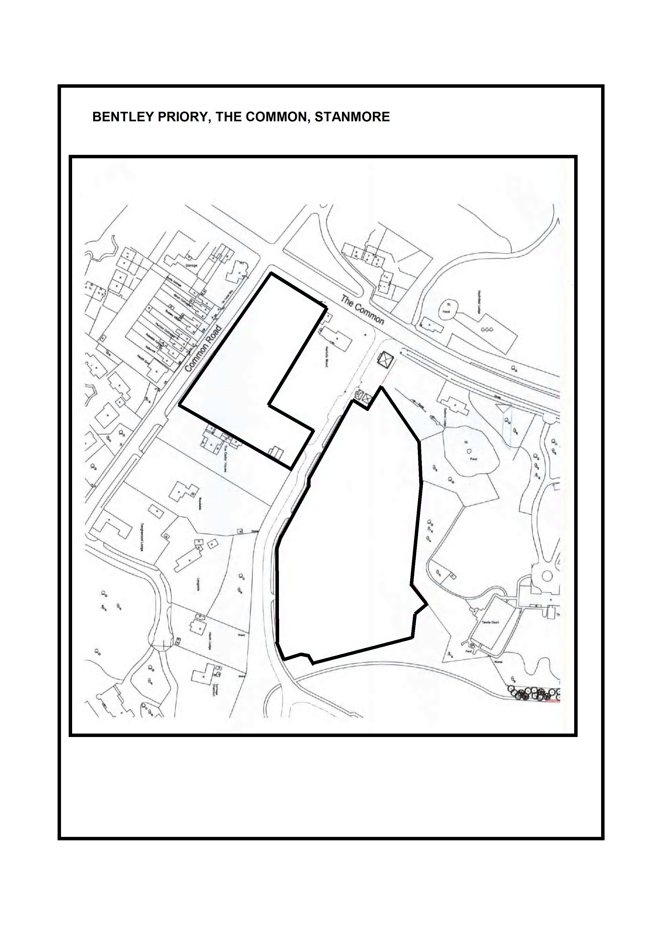

Item No. | 2/02
Address: | 25 CEDAR DRIVE, PINNER
Reference: | P/2319/12
Description: | CONVERSION OF DWELLING INTO TWO SELF-CONTAINED FLATS WITH ASSOCIATED LANDSCAPING, CYCLE AND REFUSE STORAGE; SINGLE STOREY INFILL REAR EXTENSION; CONVERSION OF GARAGE INTO HABITABLE ROOM
Ward: | HATCH END
Applicant: | MR J CHAUHAN
Agent: | STUDIO INFINITII
Case Officer: | CHERYL ANDREWS
Expiry Date: | 02/11/2012
RECOMMENDATION
GRANT planning permission for the development described in the application and submitted plans, subject to conditions.

REASON
The decision to grant planning permission has been taken having regard to the policies and proposals in The London Plan 2011, the Harrow Core Strategy 2012, the saved policies of the Harrow Unitary Development Plan 2004 and national planning policy encouraging more efficient use of land for housing, as well as to all relevant material considerations, including site circumstances and comments received in response to publicity and consultation. The proposed development is considered to be acceptable in terms of the principle of development and would not be out of keeping with the character and appearance of the area. It would not adversely affect the amenities of neighbouring occupiers or have any undue impacts on traffic, parking or refuse collection. The proposal would provide an acceptable standard of accessible living accommodation. The associated impacts that would arise from the development would be adequately ameliorated through the use of appropriate planning conditions and the development is therefore considered to be acceptable.

INFORMATION
The application is reported to the Planning Committee because the application has received a petition and in the opinion of the Divisional Director of Planning Services, the application has significant public interest and is therefore excluded by provisions A and 13 from the Scheme of Delegation dated 14 March 2012.

Statutory Return Type: 13 – Minor Dwellings
Council Interest: None
Net additional Floorspace: 20.20 sqm
GLA Community Infrastructure Levy (CIL) Contribution (provisional): £707
Site Description
- The application site is occupied by a two storey detached dwellinghouse with an existing two storey side extension incorporating a new garage (built in two stages) that links into a porch. A single storey rear extension with a width of 7.26m and depth of 4.28m spans the width of the original dwellinghouse. The existing forecourt comprises hardstanding in front of the garage with soft landscaping adjacent to the dwellinghouse.
- Adjacent detached property to the west, No.23 Cedar Drive, has a glazed door in the eastern elevation adjacent to the subject site. This serves a kitchen. There is a large window in the rear elevation that also serves this room. This elevation is offset from the shared boundary by 1.71m.
- There is a window in the side projection on the eastern flank wall that serves a WC.
- The adjacent property to the east is a large detached property.

Proposal Details
- The application proposes the conversion of the dwellinghouse into two self-contained flats with associated landscaping, cycle and refuse storage; a single storey rear infill extension and the conversion of the garage into habitable room.
- The ground floor flat would be a 2 bedroom, 4 person flat with a lounge-diner, living room, kitchen, WC and bathroom. It would have a total gross internal floor area of 108.64 sq.m.
- The first floor flat would be a 2 bedroom 3 person flat, with a living-diner-kitchen and WC. It would have a total gross internal floor area of 67.58 sq.m.
- Insertion of a door at ground floor level on the rear elevation to provide direct access from the ground floor flat to the garden.
- The rear garden would be horizontally split into two sections with a cycle shed in each garden and a screened bin enclosure adjacent to the shared pathway from the front of the property. Each cycle shed would be of a timber construction with a pitched roof. They would have the following dimensions: 1.584m ridge height, 2.030m depth and 0.834m width.
- The forecourt would have an accessible parking space, external stair lift and a mix of hard and soft landscaping.
- The application also proposes a single storey rear extension that would infill the space between the two storey side extension and single storey rear extension, including the undercroft space of the two storey side extension. It would have a flat roof with a height of 3.12m, with a rooflight. The rear element would project 4.28m from the original rear wall of the house, in line with the existing single storey rear extension. The extension would have a width of 3.45m. It would have a blank flank wall.
- Also proposed is the conversion of the garage to a habitable room. The external changes comprise the replacement of the garage door with a wall and a window on the front elevation.

Relevant History
LBH/8441
Demolition of existing garage; erection of new garage and single-storey rear extension to living room and provision of toilet
Grant – 9/1/73

LBH/31157
Pitched roof to garage and porch, first floor and two storey side extension
Grant – 17/11/86

P/1617/12
Single storey infill rear extension; conversion of garage into habitable room
Grant – 8/8/12

Pre-Application Discussion
None.

Applicant Submission Documents
Design and Access Statement

Consultations
Drainage- no comment
CIL administrator- no comment
Waste management- no comment
Landscape Architect- the landscaping is acceptable subject to conditions
Highways- no objection
Transport Planner – no comment

Notifications
Sent: 11
Replies: 32
Expiry: 9-10-12

Addresses Consulted
Cedar Drive: 21, 23, 27, 29, 32, 34, 36 and 38
8 Ashcroft
1 and 2 Oakmeade

Summary of Responses
- Concerns over higher density/conversion of a dwellinghouse into flats
- Enough flats in the area to meet demand
- Creating a precedent for conversions in the street/property developers moving in
- Detrimental effect on the community and character of the area
- Reduction in greenery
- Additional noise and disturbance
- Create parking problems, including access for emergency services and refuse collection, as only one parking space is provided. Concerns over this space not being safe for disabled people.
- Loss of privacy and light to adjoining properties
- Impact on sewerage and water systems

A petition has been received objecting to the proposal on the following grounds:
1) It will increase traffic and parking
2) It will fundamentally change the character of a residential area which is composed only of houses in which there are no flats or flat conversions
3) By approving the application the Council will be also fundamentally altering the nature of the community in the area which is made of families that have been settled in the area for a long period of time, facilitated by the presence of early 20th Century family houses.

APPRAISAL
The National Planning Policy Framework [NPPF] which consolidates national planning policy has been adopted and considered in relation to this application.

Section 38(6) of the Planning and Compulsory Purchase Act 2004 requires that:
‘If regard is to be had to the Development Plan for the purpose of any determination to be made under the Planning Acts, the determination must be made in accordance with the Plan unless material considerations indicate otherwise.’

In this instance, the Development Plan comprises The London Plan (2011), Harrow’s Core Strategy (2012) and the saved policies of the Harrow Unitary Development Plan (2004) [Saved by a Direction of the Secretary of State pursuant to paragraph 1(3) of Schedule 8 of the Planning and Compulsory Purchase Act 2004].

Whilst this application has been principally considered against the adopted Development Plan, some regard has also been had to relevant policies in the Development Management Policies DPD (Pre-submission Draft) which forms a part of the emerging Local Development Framework for the Borough and will eventually replace the Harrow Unitary Development Plan (2004) when adopted.

The document has been subject to two rounds of consultation; between 13 May 2011 and 24 June 2011 on the Council’s Preferred Options Development Management Policies, and between 27 July 2012 and 7 September 2012 on the Pre-submission Draft document. The DPD has now been sent to the Secretary of State for Examination in Public which is expected to be held in January 2013. Before this, a 4 week consultation is currently in progress between 11 October 2012 to 8 November 2012 on the Council's Proposed Minor Modifications to the DPD as a result of responses received to the Pre-submission Consultation.

MAIN CONSIDERATIONS
- Principle of Development
- Character and Appearance of the Area
- Residential Amenity
- Traffic, Parking and Refuse
- Accessibility
- S17 Crime & Disorder Act
- Consultation Responses

1) Principle of the Development
Saved policy H10 of the HUDP (2004) and Policy 3.4 of The London Plan (2011) support the re-use of existing housing and the optimisation of housing output in development proposals. The proposal would re-use an existing building and increase housing density on the site. Therefore, subject to the considerations discussed below, there is no objection in principle to the conversion of the dwellinghouse into two separate residential flats.

Policy 3.8 of The London Plan (2011) also encourages the borough to provide a range of housing choices in order to take account of the various different groups who require different types of housing. Further to this, Core Policy CS1(I) states that ‘New residential development shall result in a mix of housing in terms of type, size and tenure across the Borough and within neighbourhoods, to promote housing choice, meet local needs, and to maintain mixed and sustainable communities’. Policy 34 of the emerging Development Management Policies DPD supports the principle of the conversion of houses to multiple units. This is based on the evidence from the West London Strategic Housing Market Assessment (2010) which shows that there is a surplus of 3 bedroom homes and deficit of 2 bedroom homes in the area. Having regard to the London Plan and the Council’s policies and guidelines, it is considered that the proposed conversion of the property would constitute an increase in smaller housing stock within the borough, and would therefore be acceptable in principle. There is no specific policy in the development plan that precludes the principle of converting an existing dwellinghouse to flats. Although the concerns of objectors are noted regarding the conversion of the dwellinghouse into two flats and the possible impact of this on the demographic composition of the community, planning permission could not be reasonably withheld on this basis as the proposal complies with the above adopted policies.

2) Character and Appearance of the Area
National Planning Policy Framework (2012) advises at paragraph 58 that planning policies and decisions should aim to ensure that developments optimise the potential of the site to accommodate development whilst responding to local character and history and reflecting the identity of local surroundings and materials.

The London Plan (2011) policies 7.4B and 7.6B set out the design principles that all boroughs should seek to ensure for all development proposals. The London Plan (2011) policy 7.4B states, inter alia, that all development proposals should have regard to the local context, contribute to a positive relationship between the urban landscape and natural features, be human in scale, make a positive contribution and should be informed by the historic environment. The London Plan (2011) policy 7.6B states, inter alia, that all development proposals should; be of the highest architectural quality, which complement the local architectural character and be of an appropriate proportion composition, scale and orientation.

Core Policy CS1(B) states that ‘All development shall respond positively to the local and historic context in terms of design, siting, density and spacing, reinforce the positive attributes of local distinctiveness whilst promoting innovative design and/or enhancing areas of poor design; extensions should respect their host building.’

Saved policy D4 of the Harrow UDP reinforces the principles set out under The London Plan (2011) policies 7.4B and 7.6B and seeks a high standard of design and layout in all development proposals. It goes on to state, amongst other things, that developments should contribute to the creation of a positive identity through the quality of building layout and design, should be designed to complement their surroundings, and should have a satisfactory relationship with adjoining buildings and spaces.

Notwithstanding the insertion of a door in the rear elevation and a proposed rooflight on the flat roof, the footprint, size, massing, bulk, design and siting of the proposed single storey rear infill extension and the external alterations associated with the conversion of the garage to a habitable room are identical to that approved under previous planning application P/1617/12 dated 8/8/12. The development plan and site circumstances have not altered since this application was determined. These elements of the proposal still comply with all of the relevant policies and guidance and could not therefore be refused planning permission under this application. The proposed door and rooflight, due to their siting and minor nature, are considered to be acceptable.

Forecourt Treatment

Paragraph 5.5 of the SPD states: “the layout of the forecourt should comply with the relevant provisions set out in the Council's Accessible Homes SPD and should make provision for soft landscaping of the parts of the forecourt not needed to provide car parking space and access to the premises”.

The forecourt would have an accessible parking space with a width of 3.3m and a stair lift adjacent to this leading to the communal entrance. A hardsurfaced pathway from the front entrance would provide a convenient route to the rear garden and bin storage area. There would be soft landscaping covering the remainder of the forecourt, which comprises nearly half of the overall surface area. This is considered to strike an acceptable balance between meeting accessibility requirements and providing soft landscaping which would enhance the suburban character and visual appearance of the property.

3) Residential Amenity
Policy 7.6B, subsection D, of The London Plan (2011) states that new buildings and structures should not cause unacceptable harm to the amenity of surrounding land and buildings, particularly residential buildings, in relation to privacy and overshadowing. Following on from this, Criterion C of saved policy D5 of the HUDP (2004) seeks to “ensure that the amenity and privacy of occupiers of existing and proposed dwellings is safeguarded”.

Impact on the Amenity of the Neighbouring Occupiers:
The existing single family dwellinghouse has the potential to accommodate eight to ten persons. The dwellinghouse converted to two separate residential units (as proposed under the current planning application) would potentially accommodate up to 9 persons.

Whilst it is acknowledged that the proposed subdivision of the dwellinghouse into two separate households may increase residential activity on the site, expressed through comings and goings to the property, it is considered that any increase would not be unduly detrimental to the amenity of neighbouring occupiers, in terms of increased disturbance and activity.

The impact of the proposed single storey rear infill extension and physical alterations associated with the conversion of the garage to a habitable room on adjoining neighbours were appraised under the previously granted planning application P/1617/12 as follows:

The London Plan policy 7.6B states that buildings and structures should not cause unacceptable harm to the amenity of surrounding land and buildings, particularly residential buildings, in relation to privacy and overshadowing. Saved policy D5 of the Harrow UDP states that new residential development should safeguard the amenity and privacy of occupiers of existing and proposed dwellings.

The extension would exceed the 4m depth recommended in the SPD by 0.28m and the 3m recommended height at the boundary by 0.12m. However, the eastern elevation of No.23 Cedar Drive is set away from the shared boundary by 1.71m and the rear wall of the dwellinghouse is set 2.88m rearward of the original rear wall of the subject property. The proposal would also be sited to the north-east of No.23.

Paragraph 6.26 of the SPD defines protected windows as “main or primary windows to habitable rooms and kitchens over 13sq.m”. There is a glazed door in the eastern flank wall of No.23 serving a kitchen. This is not protected as there is another large window in the rear elevation serving the same room. The window in the WC also does not fall under the definition of a protected window. The proposal would project 1.32m rearward of the rear wall of No.23 and would be 1.71m away from the house because of the gap between No.23 and the shared side boundary with No.25.

For these reasons, it is considered that the proposal would not have a significant harmful impact upon the residential amenities of the occupiers of No.23 in terms of loss of light or outlook. The proposal would have a blank flank wall and would therefore not cause a loss of privacy. The proposal would be screened from No.25 by the existing extension.

The conversion of the garage to a habitable room would not have a discernable impact upon residential amenity. The proposed rear infill extension and conversion of the garage to a habitable room are therefore considered to comply with the policies stated above.

The proposed decking immediately adjoining the rear of the ground floor flat would have a modest height of 0.13m and would therefore not result in any overlooking into neighbouring properties.

Impact on the Amenity of the Intended Occupiers of the Flats
- Private Amenity Space
Saved policy D5 of the Harrow Unitary Development Plan (2004) requires new development ‘to provide amenity space which is sufficient: to protect the privacy and amenity of occupiers of surrounding buildings; as a usable amenity area for the occupiers of the development; as a visual amenity’. Paragraph 5.16 of the adopted SPD states that ‘The Council will seek to ensure that all flats (except for the conversion of maisonettes above shops and mid terrace properties) have access to a garden’.

The submitted plan indicates that the rear garden area would be horizontally split into two areas, a garden at the rear directly accessed from the ground floor flat and a garden for the first floor flat behind this, accessed via a communal pathway from the front of the house. This is considered to be acceptable and would satisfy the requirements of paragraph 5.16 of the SPD. There would be screening on the boundaries and the decking would have potted trees to soften its appearance. A 1.8m high wooden fence would separate the gardens, providing adequate privacy. The proposed cycle storage sheds would be of an acceptable scale, design and material.

- Refuse Storage
Paragraph 5.8 of the SPD states the conversion of one house into two flats results in the need to accommodate six bins; these can be visually obtrusive when located in the forecourt. The preferred solution is to site these bins at the rear or side of the building. The proposal complies with this guideline and the bins would be sited in an accessible location within an enclosure that would be screened from the ground floor garden by soft landscaping.

- Room Size and Layout
Table 3.3 of the recently adopted London Plan (2011) specifies minimum Gross Internal Areas (GIA) for residential units. Paragraph 3.36 of the London Plan (2011) specifies that these are minimum sizes and should be exceeded where possible. The use of these residential unit GIA’s as minima is also reiterated in Appendix 1 of the Council’s adopted SPD. As the London Plan (2011) has recently been adopted, the flat size GIA’s have considerable weight.

In view of paragraphs 56 and 57 of the National Planning Policy Framework (2012), when considering what is an appropriate standard of accommodation and quality of design the Council is mindful of the Interim London Housing Design Guide 2010 (ILHDG). The former Draft London Housing Design Guide was assessed by examination in public between 28th June - 8th December 2010 and the Panel’s Report was completed in March 2011. This then became the Interim Design Guide and it provides residential unit Gross Internal Area’s (GIA’s) and additional minimum dimensions for rooms within the residential unit. The GIA’s in this Interim Design Guide are incorporated into policy 3.5 of The London Plan (2011). Further to this, the above-mentioned room sizes are incorporated into the Mayors Housing Supplementary Planning Document, which is a material planning consideration.

The room sizes of the current scheme are shown in the table below, along with the minimum floor areas for rooms as recommended by the ILHDG (2010).

 | Gross Internal floor Area (specified in The London Plan 2011) | Kitchen/Living/Dining | Bedroom
ILHDG 2010 | 2 bedroom, 4 persons  70 m² | 4 persons  27m² | Double  12m²
GROUND FLOOR FLAT | 108.64m² | 58.82m² | 16.43m²  11.92m²
ILHDG 2010 | 2 bedroom, 3 persons  61 m² | 3 persons  25m² | Double 12m²  Single 8 m²
FIRST FLOOR FLAT | 67.58m² | 24.22m² | 14.43m2  12.87m2

With reference to the above table, it is considered that an acceptable overall Gross Internal Area has been provided for the flats. It is noted that the kitchen/living/dining area of the first floor flat is slightly under the minimum standard suggested in the guidance. Notwithstanding this, and given the constraints related to the conversion of an existing house, it is considered that the layout and provision of large windows in each habitable room would provide acceptable living conditions that would not be cramped or substandard. The ground floor flat would also meet the minimum space standards for a six person, three bedroom unit, notwithstanding a modest deficit of 0.08 square metres for the second bedroom.

- Stacking Arrangements
Paragraph 5.12 of the Council’s adopted Supplementary Planning Document – Residential Design Guide (2010) states that the design and layout of conversions should minimise the potential for noise transfer between new homes. The vertical stacking of rooms between flats should ensure that bedrooms do not overlap living rooms, kitchens and bathrooms on other floors’.

The vertical arrangement of habitable rooms between the ground floor flat and the first floor flat generally stacks similar rooms together. However, it is noted that Bedroom 1 within the first floor flat would be sited over the lounge-diner area of the ground floor flat. However, given the constraints related to the conversion of an existing house, and the provision of second bedroom in this first floor unit that would be sited over another bedroom, it is considered that this would not be a sufficient and justifiable reason to warrant a refusal.

4) Traffic, Parking and Refuse
The London Plan (2011) Policies 6.3, 6.9 and 6.13 seek to regulate parking in order to minimise additional car travel, reduce trip lengths and encourage the use of other, more sustainable means of travel. The Parking Addendum to Chapter 6 of The London Plan (2011) sets out maximum parking standards for new development, dependent upon their use and level of public transport accessibility. Policy T6 of the Harrow Unitary Development Plan (2004) requires new development to address the related travel demand arising from the scheme and policy T13 requires new development to comply with the Council’s maximum car parking standards.

"The existing 'baseline' consists of a 3 bedroom single dwelling which has an extant permission to extend to a 4/5 bed single dwelling unit capable of housing up to 10 persons. The current proposal for two 2 bedroom flats would marginally intensify potential occupancy as compared to the existing 3 bedroom arrangement and require a maximum parking provision of 2 spaces in line with London Plan 2011 parking standards. However, when compared to the extant permission to extend to 4/5 bedrooms the difference between this raised baseline and the flatted proposal is very marginal and person occupancy for both cases is potentially comparable.

The scenario provides for 1 space, which the Council’s Traffic and Parking Engineer considers to be acceptable, given that there is some (albeit limited) parking availability in Cedar Drive and neighbouring side roads. In traffic generation terms, any potential increase would be marginal and hence does not raise any specific concerns. The proposal is not considered to have a material impact on access for emergency service and refuse collection vehicles.

Secure and readily accessible cycle parking is shown on the plans, with one space per unit. For these reasons, the Council's Highways Engineer has raised no objection to the proposal and it is considered to comply with the policies stated above.

5) Accessibility
Saved Policies D4 and C16 of the Harrow Unitary Development Plan (2004) and policy 3.8 of The London Plan (2011) seek to ensure that all new housing is built to the Lifetime Homes standard. Furthermore, The London Plan (2011) policy 7.2 requires all future development to meet the highest standards of accessibility and inclusion. An appeal decision at No.72B Marlborough Hill (ref APP/M5450/C/10/2135771) has confirmed that this policy should be given significant weight when assessing planning applications. Paragraph 1.17 of the Council’s Supplementary Planning Document - Accessible Homes (2010) states that “The ground floor flat in a conversion scheme will be expected to be a Wheelchair Home’.

The proposed plans and Design and Access Statement demonstrate that the proposed ground floor flat would meet all relevant Lifetime Homes standards (‘LHS’) and would not be prejudicial to the occupation of the dwelling by a wheelchair user. It would provide spacious accommodation with adequate turning and circulation space for wheelchairs (LHS 7, 10 and 14). Door widths would meet LHS 6 and the proposal would have an accessible car parking space and entrance (LHS 1, 2, 3, 4). There is an accessible WC with convenient access from most areas of the flat (LHS 13, 14) and the accommodation is at ground floor level (LHS 8, 9).

The first floor flat could not be classed as a Lifetime Home due to the stairs not being ‘easy going’. However, it is an existing house and it would comply with the other relevant Lifetime Homes standards listed above and is therefore considered to be acceptable.

6) S17 Crime & Disorder Act
Policy D4 of the Harrow Unitary Development Plan (2004) advises that crime prevention should be integral to the initial design process of a scheme. Policy 7.3 of The London Plan (2011) seeks to ensure that developments should address security issues and provide safe and secure environments. It is deemed that this application would not have any detrimental impact upon community safety and is therefore acceptable in this regard.

7) Consultation Responses
- Creating a precedent for conversions in the street: each planning application is assessed on its own merits and this proposal would not have an effect on future planning applications for conversions in the street.
- Property developers moving in: property ownership is not material planning consideration.
- Impact on sewerage and water systems: this is not material planning consideration. However, Thames Water will usually deal with these issues.

CONCLUSION
For all the reasons considered above, and weighing up the development plan policies and proposals, and other material considerations including comments received in response to notification and consultation as set out above, this application is recommended for grant.

CONDITIONS
1 The development hereby permitted shall be begun before the expiration of three years from the date of this permission.
REASON: To comply with the provisions of Section 91 of the Town and Country Planning Act 1990.

2 The development hereby permitted shall not be occupied until there has been submitted to, and approved in writing by, the local planning authority, a scheme of soft landscape works to the front of the application site. Soft landscape works shall include: planting plans, and schedules of plants, noting species, plant sizes and proposed numbers / densities.
REASON: To safeguard the appearance and character of the area, and to enhance the appearance of the development in accordance with Policies D4 and D9 of the Harrow Unitary Development Plan (2004).

3 All planting, seeding or turfing comprised in the approved details of landscaping shall be carried out in the first planting and seeding seasons following the occupation of the building, or the completion of the development, whichever is the sooner. Any existing or new trees or shrubs which, within a period of 5 years from the completion of the development, die, are removed, or become seriously damaged or diseased, shall be replaced in the next planting season, with others of a similar size and species, unless the local authority agrees any variation in writing.
REASON: To safeguard the appearance and character of the area, and to enhance the appearance of the development in accordance with Policies D4 and D9 of the Harrow Unitary Development Plan (2004).

4 The materials to be used in the construction of the external surfaces of the extensions hereby permitted shall match those used in the existing building.
REASON: To safeguard the appearance of the locality in accordance with saved policy D4 of the Harrow Unitary Development Plan (2004).

5 The roof area of the single storey rear extension hereby permitted shall not be used as a balcony, roof garden or similar amenity area without the grant of further specific permission from the local planning authority.
REASON: To safeguard the amenity of neighbouring residents and comply with saved policy D5 of the Harrow Unitary Development Plan (2004).

6 The refuse and waste bins shall be stored at all times, other than on collection days, in the designated refuse storage area, as shown on the approved drawing.
REASON: To safeguard the appearance of the locality in accordance with saved policy D4 of the Harrow Unitary Development Plan (2004).

7 The development hereby permitted shall be carried out in accordance with the following approved plans: SI/2012005/22, SI/2012005/23 Rev.C, SI/2012005/24 Rev.B, SI/2012005/25, SI/2012005/26 Rev.B, SI/2012005/28 Rev.A, SI/2012005/21, SI/2012005/27 Rev.B, Site Plan.
REASON: For the avoidance of doubt and in the interests of proper planning.

INFORMATIVES
1 REASON FOR GRANT OF PLANNING PERMISSION
The decision to grant planning permission has been taken having regard to the policies and proposals in The London Plan 2011, the Harrow Core Strategy 2012, the saved policies of the Harrow Unitary Development Plan 2004 and national planning policy encouraging more efficient use of land for housing, as well as to all relevant material considerations, including site circumstances and comments received in response to publicity and consultation. The proposed development is considered to be acceptable in terms of the principle of development and would not be out of keeping with the character and appearance of the area. It would not adversely affect the amenities of neighbouring occupiers or have any undue impacts on traffic, parking or refuse collection. The proposal would provide an acceptable standard of accessible living accommodation. The associated impacts that would arise from the development would be adequately ameliorated through the attached planning conditions and the development is therefore considered to be acceptable.

The following policies are relevant to this decision:

National Planning Policy Framework (2012)

The London Plan (2011):
3.3 – Increasing Housing Supply
3.4 – Optimising Housing Potential
3.5 – Quality and Design of Housing Developments
3.8 – Housing Choice
6.3 – Assessing the effects of development on transport capacity
6.9 – Cycling
6.13 - Parking
7.2 – An Inclusive Environment
7.3 – Designing Out Crime
7.4 – Local Character
7.6 – Architecture

The Harrow Core Strategy (2012)
Core Policy CS 1(B) CS 1(I) CS1 (K) – Overarching Policy

Saved Policies of the London Borough of Harrow Unitary Development Plan (2004):
D4 – The Standard of Design and Layout
D5 – New Residential Development – Amenity Space and Privacy
D9 – Streetside Greenness and Forecourt Greenery
H10 – Maintenance and Improvement to Existing Housing Stock
T6 – The Transport Impact of Development Proposals
T13 – Parking Standards
C16 – Access to Buildings and Public Spaces
EP25 – Noise

Supplementary Planning Documents / Guidance:
Supplementary Planning Document – Residential Design Guide (2010)
Supplementary Planning Document - Accessible Homes (2010)
Code of Practice for Storage and Collection of Refuse and Materials for Recycling in Domestic Properties (2008)

2 INFORMATIVE:
Please be advised that approval of this application by Harrow Council will attract a liability payment of £707 of Community Infrastructure Levy. This charge has been levied under Greater London Authority CIL charging schedule and s211 of the Planning Act 2008. The charge has been calculated on the proposed net increase in floorspace.

Harrow Council as CIL collecting authority on commencement of development will be collecting the Mayoral Community Infrastructure Levy (CIL).

Your proposal is subject to a CIL Liability Notice indicating a levy of £707 for the application, based on the levy rate for Harrow of £35/sqm and the calculated net additional floorspace of 20.2 sqm

You are advised to visit the planning portal website where you can download the appropriate document templates.

http://www.planningportal.gov.uk/planning/applications/howtoapply/whattosubmit/cil

3 CONSIDERATE CONTRACTOR CODE OF PRACTICE
The applicant's attention is drawn to the requirements in the attached Considerate Contractor Code of Practice, in the interests of minimising any adverse effects arising from building operations, and in particular the limitations on hours of working.

4 PARTY WALL ACT:
The Party Wall etc. Act 1996 requires a building owner to notify and obtain formal agreement from adjoining owner(s) where the building owner intends to carry out building work which involves:
1. work on an existing wall shared with another property;
2. building on the boundary with a neighbouring property;
3. excavating near a neighbouring building,
and that work falls within the scope of the Act.
Procedures under this Act are quite separate from the need for planning permission or building regulations approval.
“The Party Wall etc. Act 1996: Explanatory booklet” is available free of charge from:
Communities and Local Government Publications, PO Box 236, Wetherby, LS23 7NB
Please quote Product code: 02 BR 00862 when ordering
Also available for download from the CLG website:
http://www.communities.gov.uk/documents/planningandbuilding/pdf/133214.pdf
Tel: 0870 1226 236 Fax: 0870 1226 237
Textphone: 0870 1207 405
E-mail: communities@twoten.com
5 COMPLIANCE WITH PLANNING CONDITIONS
IMPORTANT INFORMATIVE: Compliance With Planning Conditions Requiring Submission and Approval of Details Before Development Commences
- You will be in breach of planning permission if you start development without complying with a condition requiring you to do something before you start. For example, that a scheme or details of the development must first be approved by the Local Planning Authority.
- Carrying out works in breach of such a condition will not satisfy the requirement to commence the development within the time permitted.
- Beginning development in breach of a planning condition will invalidate your planning permission.
- If you require confirmation as to whether the works you have carried out are acceptable, then you should apply to the Local Planning Authority for a certificate of lawfulness.

Plan Nos: SI/2012005/22, SI/2012005/23 Rev.C, SI/2012005/24 Rev.B, SI/2012005/25, SI/2012005/26 Rev.B, SI/2012005/28 Rev.A, SI/2012005/21, SI/2012005/27 Rev.B, Site Plan

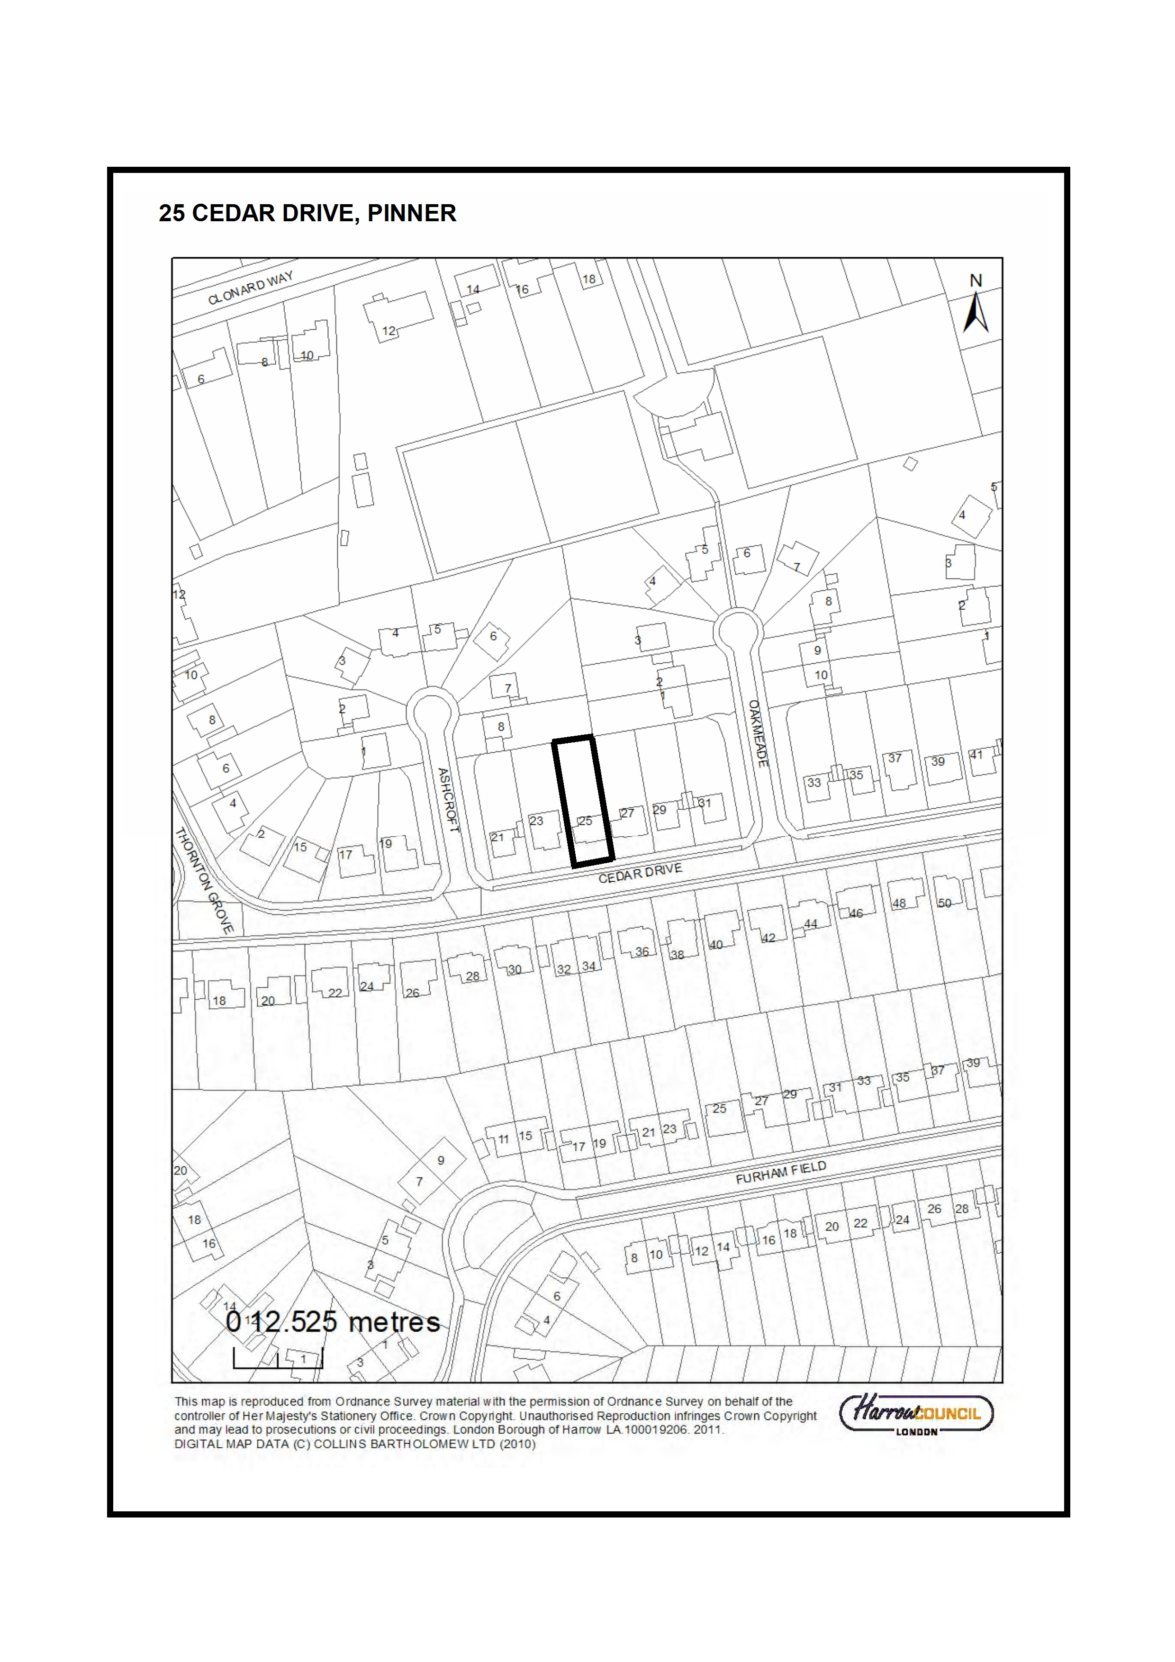
SECTION 3 - OTHER APPLICATIONS RECOMMENDED FOR REFUSAL

Item No. | 3/01
Address: | 6 AYLWARDS RISE, STANMORE
Reference: | P/1767/12
Description: | SINGLE AND TWO STOREY SIDE AND REAR EXTENSIONS; THREE REAR AND TWO SIDE DORMERS; EXTERNAL ALTERATIONS
Ward: | STANMORE PARK
Applicant: | MR & MRS A. SHARMA
Agent: | THE DRAWING ROOM (LONDON) LTD.
Case Officer: | ABIGAIL HEARD
Expiry Date: | 20/08/2012
RECOMMENDATION
REFUSE permission for the development described in the application and submitted plans for the following reason(s):

REASON
1 The proposed first floor rear extension, by reason of height, bulk, rearward projection and close proximity to the boundary with No.7 Aylwards Rise, would be unduly obtrusive, overbearing and oppressive and would result in an unreasonable loss of outlook being experienced by No. 7 Aylwards Rise to the detriment of their residential amenities, contrary to Policy 7.6B of The London Plan (2011), saved Policy D5 of the Harrow Unitary Development Plan (2004) and the adopted Supplementary Planning Document: Residential Design Guide (2010).

2 The dormers proposed to serve bedrooms 5 and 6 in the side elevation and dormer proposed to serve the games room in the rear elevation would result in an unacceptable level of actual and perceived overlooking of the private rear amenity areas of No. 5 and No. 7 Aylwards Rise, to the detriment of their residential amenities, contrary to Policy 7.6B of The London Plan (2011), saved Policy D5 of the Harrow Unitary Development Plan (2004) and the adopted Supplementary Planning Document: Residential Design Guide (2010).

Statutory Return Type: Householder Development
Council Interest: None
Gross Floorspace: 640.27 sqm
Net additional Floorspace: 244 sqm
GLA Community Infrastructure Levy (CIL) Contribution (provisional): £8, 540

Site Description
- The application site lies within the Harrow Weald Ridge Area of Special Character.
- The subject site is irregular shaped and located at the north western head of Aylwards Rise, which is a private cul-de-sac. Due to the subject site's location at the end of this cul-de-sac, the neighbouring properties at No’s 5 and 7 are located to the north east and south east, respectively.
- A large, two storey detached dwellinghouse is located within the front part of the site, setback approximately 12.0 m from the road boundary. This dwellinghouse has been constructed in the arts and crafts style and includes render clad brick and exposed brick on external walls at ground floor level; and hanging tiles on the external walls at first floor level. A tile clad hipped roof covers much of this dwellinghouse, although catslide roofs are located over the north eastern and south eastern wings seen from Aylwards Rise.
- The original dwellinghouse has been extended in several phases. A two storey rear extension has been added to the rear or north western elevation (ref: LBH/24935). Two storey side extensions were added to the flank or south eastern elevation and single storey side to rear extensions have been added to the north eastern elevation (ref: E/50/93). As part of these latter extensions, the catslide roofs visible today were also added.
- A single storey rear extension has also been added to the rear or south western elevation (ref: E/766/98).
- The rear part of the site contains a large garden that slopes away from the dwellinghouse. This garden covers approximately three quarters of the site, has a maximum depth of approximately 35 m and a width that varies from approximately 13 m to 31 m. This garden is largely lawn covered with mature vegetation, including a TPO tree located around its periphery.
- That part of the site located between the road and the front of the dwellinghouse is covered in hardstanding that is used for the parking and manoeuvring of vehicles as well as providing vehicular access to the garages located in the north eastern and south eastern wings.
- Like the subject site, Aylwards Rise contains large detached dwellinghouses on large sites. These dwellinghouses have been constructed in a range of styles, ranging from arts and crafts to more contemporary designs.

Proposal Details
- The application seeks planning permission for the erection of a large two storey rear extension with a pitched roof, two storey side extension with pitched roof and five dormers in the extended side and rear roofslopes.
- The application also includes the erection of a first floor rear extension which is proposed to tie an existing two storey projecting extension into the proposed two storey rear extension
- Three dormers characterised by flat roofs are proposed on the rear roofslope and will serve a bedroom, bathroom and games room within the roofspace.
- Two dormers are proposed to be located on the side roofslope and will serve bedrooms

Revisions to Previous Application
Following the previous decision (P/2699/11) the following amendments have been made;
- Removal of the first floor extension to the north east and as such the catslide roof will be retained
- The dormer to the front of the scheme is proposed to be removed from the development
- The two storey extension to the rear of the dwelling is now proposed to extend across the majority of the rear elevation of the existing building

Relevant History

P/2699/11
Partial demolition of existing garage; partial demolition and reconstruction of existing roof; two storey side extension on north eastern side of property; single & two storey rear extension; front; rear and side dormers; canopy porch on front elevation; external alterations; internal demolition and reconfiguration
Refused - 12/12/11; Appeal Dismissed - 04/05/12

Reasons for Refusal:
1. The proposed extensions, by reason of their size, siting and design, would have excessive bulk, would be unduly obtrusive, infilling space between the property and its neighbours, incongruous and overbearing and would detract from the established pattern of development in the street scene and the character and appearance of the locality and the dwellinghouse, contrary to Policies 7.4B and 7.6B of The London Plan (2011), saved Policies D4 and EP31 of the Harrow Unitary Development Plan and the adopted Supplementary Planning Document: Residential Design Guide (2010).
2. The proposed two storey side and rear extensions, by reason of excessive height, rearward projection and close proximity to boundaries, would be unduly obtrusive, overbearing and oppressive and would result in unreasonable overshadowing and loss of outlook being experienced by No’s 5 and 7 Aylwards Rise to the detriment of their residential amenities, contrary to Policies 7.4B and 7.6B of The London Plan (2011), saved Policy D5 of the Harrow Unitary Development Plan (2004) and the adopted Supplementary Planning Document: Residential Design Guide (2010).
3. The proposed side dormer would result in direct and perceived overlooking of private amenity areas and rooms at No. 5 Aylwards Rise, to the detriment of their residential amenities, contrary to Policy 7.6B of The London Plan (2011), saved Policy D5 of the Harrow Unitary Development Plan (2004) and the adopted Supplementary Planning Document: Residential Design Guide (2010).

P/0629/11 - Partial Demolition of Existing Garage; two storey side extension on south eastern side of property; two storey and first floor front extensions; two storey side extension on north western side of property; single & two storey rear extension; front; rear and side dormers; canopy porch on front elevation; external alterations - Withdrawn

EAST/766/98/FUL
Single and two storey rear extension
Granted 28/10/98

EAST/50/93/FUL
Two storey side single storey side to rear extension
Granted 10/05/93

EAST/45844/92/FUL
Attached double garage and single storey side to rear extension
Granted 22/01/93 - Application not implemented

LBH/24935
Two storey rear extension
Granted 05/04/84

HAR/12755
Erection of House & Garage
Granted 22/03/57

Pre-Application Discussion
- The principle of two storey extensions over the north eastern and south eastern wings of the dwellinghouse; and front and side dormer windows are considered to be unacceptable. Rear dormers would be acceptable. However, provided they meet the design requirements of the Supplementary Planning Document: Residential Design Guide (2010)
- A first floor rear extension and a two storey rear extension would be considered acceptable subject to scale and design

Applicant Submission Documents
- Arboricultural report

Consultations
Tree Officer: No trees are proposed for removal to facilitate the proposed extension(s). The Maple at the front can be fenced off as per the submitted Tree Protection Plan – the remaining area at the front (existing hard surface/driveway) can be used for storage of materials etc. The groundworks required for the rear extension will necessitate some incursion into the RPA of the Oak (belonging to adjoining garden) however this would be 10% or less of the RPA, and is therefore acceptable. Provided the Tree Protection Plan & Method Statement are implemented exactly as specified there should be no adverse impact on the on-site / adjoining trees

Advertisement
n/a

Notifications
Sent: 8
Replies: 2
Expiry: 22-08-12

Addresses Consulted
20, 22 Aylmer Drive
2, 5, 7 Aylwards Rise
16, 17, 18 Fallowfield

Summary of Responses
- Overlooking from dormers in the side elevation facing Fallowfield
- Rear extension has an overbearing impact on neighbouring occupiers
- The proposed extension is incongruous and will be out of keeping with the character of the existing dwelling
- Inspectors reasons for refusal of the previous application have not been fully considered
- The extension will result in a loss of privacy for no. 7 Aylwards Rise and the removal of boundary trees will further exacerbate this
- Overdevelopment

APPRAISAL

MAIN CONSIDERATIONS
- Character and Appearance of the Area
- Residential Amenity
- Trees and new development
- S17 Crime & Disorder Act
- Consultation Responses

1) Character and Appearance of the Area
Policy 7.4 of The London Plan (2011), Core Policy CS1 of the Harrow Core Strategy (2012) and saved policy D4 of the Harrow Unitary Development Plan (UDP) all require that new development should have a high standard of design and layout and should be of a scale and proportion that complements surrounding development and the area. The application site also lies within the Harrow Weald Ridge Area of Special Character and Policy EP31 of the Harrow Unitary Development Plan specifies that the Council will resist the loss of, or damage to features that contribute to the area; protect skylines from intrusive development; and ensure that redevelopment schemes preserve or improve the character and appearance of the area.

The Planning Inspectorate dismissed the previous appeal stating 'Taken as together, the original appearance of the host property would be harmed, the final altered dwelling would lack design quality and there would not be appropriate reflection of the character of properties found locally or sufficient regard to the streetscene'. The Inspector specifically raised concerns with regard to the two storey vertical walling which was considered too close to the boundaries and such would loose the sense of space which prevails in this part of the street. The Inspector also had concerns with regard to the proposed roof which had awkward junctures and in parts lacked subservience to the original dwelling.

The catslide roofs are now proposed to remain on the north east and south east boundary. A two storey side extension will be visible from the street. However, it will be set back a significant distance (approximately 9m) from the front building line and as such is considered subservient to the existing house. In light of this it is not considered that the development will result in the loss of a sense of space in this part of the street and furthermore it will not be to the detriment of the character and appearance of the host dwelling.

In light of the above, it is considered that the proposed development will not have a detrimental impact on the character and appearance of the immediate streetscene or the Harrow Weald Ridge Area of Special Character. This is considered to address reason No. 1 of the previously refused scheme (P2699/11).

2) Residential Amenity
Policy 7.6B, subsection d, of The London Plan (2011) states that new buildings and structures should not cause unacceptable harm to the amenity of surrounding land and buildings, particularly residential buildings, in relation to privacy, overshadowing, wind and microclimate. In addition, policy 7.6B of The London Plan, saved policy D5 of the UDP require that new development should safeguard the privacy of neighbouring occupiers. These development plan policies, amongst others, are supported by the Council’s adopted Supplementary Planning Document: Residential Design Guide (SPD). This SPD was adopted in December 2010 following extensive consultation and revision in the light of consultation responses and carries significant weight as a material planning consideration. The SPD provides detailed guidance on the types of residential extension that can be considered acceptable

The first floor rear extension on the south eastern elevation would be located on an existing single storey rear extension that is on a higher ground than No. 7 and immediately adjacent to outdoor amenity space on that property. This difference in levels, coupled with the height of the proposed first floor rear extension would cause the extension to loom over this private outdoor amenity space, resulting in an obtrusive and overbearing form of development that would be unreasonably detrimental to the residential amenities of that property. Whilst it is acknowledged that there is some intervening vegetation on the subject site, between the proposed first floor rear extension and No. 7, this vegetation is not the subject of a Tree Preservation Order. As such, it could be felled at a future date. Notwithstanding this, the height and density of this vegetation is considered insufficient to adequately screen the first floor rear extension from No. 7. Further to this, there are a number of rear dormers proposed as part of the development and it is considered that the dormer proposed to serve the Games room will cause an unacceptable level of overlooking and perceived overlooking of the rear amenity space of No. 7 Aylwards Rise. Whilst it is acknowledged that the dormer will not look directly into a window, the dormer will from its elevated position overlook the rear amenity space to an unacceptable level.

Further to the above, two dormer windows are also proposed in the side elevation to serve bedrooms 5 and 6. The dormers would not look directly into a habitable room of No.5 Aylwards Rise. However, they will overlook an area of garden which is well used by the occupiers of No. 5 Aylwards Rise. In light of this, it is considered that the dormers will have an unacceptable impact on the amenities of the neighbouring occupiers of 5 Aylwards Rise, through actual and perceived overlooking. The issue of overlooking from the proposed side dormers was raised by the Local Planning Authority and Planning Inspectorate in the previous scheme. Whilst the location of the dormers have been amended to be set further from the boundary, it is still considered that the dormers proposed to serve bedrooms 5 and 6 will cause an unacceptable level of actual and perceived overlooking to the detriment of the amenities of No. 5 Aylwards Rise and the Inspectors previous concerns remain.

The proposed development will therefore conflict with Government guidance contained within the NPPF, policy 7.6B of The London Plan 2011, saved policy D5 of the Harrow Unitary Development Plan and the adopted Supplementary Planning Document: Residential Design Guide (2010) which seek to ensure interalia that development proposals safeguard the amenities of neighbouring occupiers.

3) Trees and New Development
Under the provisions of saved Policy D10 of the HUDP, the applicant is required to submit a site survey which details all existing trees shrubs, including their height, age, spread and health. Furthermore, the survey should indicate which trees are to be retained, what methods of protection are to be employed and which trees are to be lost.

The applicant does not propose to remove any trees from the subject site. The applicant has also submitted an Arboricultural Impact Assessment and Arboricultural Method Statement outlining measures to protect tress on-site and overhanging from neighbouring sites. These documents have been reviewed by the Tree Officer, and found acceptable. Were the development considered acceptable, a condition could be attached requiring that all works are carried out in accordance with the Arboricultural Impact Assessment and Arboricultural Method Statement.
4) S17 Crime & Disorder Act
It is deemed that this application would not have any detrimental impact upon community safety and is therefore acceptable in this regard.

5) Consultation Responses
- Overlooking from dormers in the side elevation facing Fallowfield: It is considered that the dormer proposed to serve bedroom 6 will cause an unacceptable level of overlooking of No. 5 Aylwards Rise. This has been addressed within section 2 of the appraisal above.
- Rear extension has an overbearing impact on neighbouring occupiers: The rear extension is considered to have an unacceptable overbearing impact on No. 7 Aylwards Rise to the detriment of the amenities of the occupiers. This has been addressed within section 2 of the appraisal above.
- The proposed extension is incongruous and will be out of keeping with the character of the existing dwelling: The design of the extension is considered acceptable and not to the detriment of the character and appearance of the original dwellinghouse, given the retention of the catslide roofs and minimal changes to the front of the building. This has been addressed within section 1 of the appraisal above.
- Inspectors reasons for refusal of the previous application have not been fully considered: It is considered that concerns with regard to the impact of the development on the character of the streetscene have been addressed. There are, however, still concerns with regard to the impact of the development on the amenities of the neighbouring occupiers which the Planning Inspector previously raised.
- The extension will result in a loss of privacy for No. 7 Aylwards Rise and the removal of boundary trees will further exacerbate this: It is considered that the proposed development will have an unacceptable impact on the amenities of the occupiers of No.7 Aylwards Rise in respect of overlooking and the overbearing impact of the proposed development. This has been addressed within section 2 of the appraisal above.
- Overdevelopment: Whilst it is considered that the proposed development will not be to the detriment of the character and appearance of the streetscene, it is considered that the proposal will be to the detriment of the amenities of the neighbouring occupiers and as such the application will result in overdevelopment of the site.

CONCLUSION
The proposed extensions are not highly visible within the streetscene and will not result in the significant remodelling of the front elevation of the dwelling. As such, the proposal is considered not to have a detrimental impact on the character and appearance of the immediate streetscene and the Harrow Weald Ridge Area of Special Character. The proposed first floor rear extension, by reason of height, bulk, rearward projection and close proximity to the boundary with No.7 Aylwards Rise, would, however, be unduly obtrusive, overbearing and oppressive and would result in an unreasonable loss of outlook being experienced by No. 7 Aylwards Rise to the detriment of their residential amenities. Furthermore, the dormer windows proposed in the rear elevation to serve the games room and the dormer windows proposed in the side elevation to serve bedrooms 5 and 6 would result in an unacceptable level of actual and perceived overlooking of the private rear amenity areas of No. 5 and No. 7 Aylwards Rise, to the detriment of their residential amenities. The proposed development is therefore contrary to Government guidance contained within the National Planning Policy Framework, Policy 7.6B of The London Plan (2011), saved Policy D5 of the Harrow Unitary Development Plan (2004) and the adopted Supplementary Planning Document: Residential Design Guide (2010)

For all the reasons considered above, and weighing up the development plan policies and proposals, and other material considerations including comments received in response to notification and consultation as set out above, this application is recommended for refusal.
INFORMATIVE
1 REASON FOR REFUSAL OF PLANNING PERMISSION
The decision to refuse planning permission has been taken having regard to national planning policy, the policies in Harrow Core Strategy 2012, the policies of The London Plan 2011 and the saved policies of the Harrow Unitary Development Plan 2004 (listed below), as well as to all relevant material considerations.

The following policies are relevant to this decision:

National Planning Policy Framework (2012)

The London Plan (2011):
7.1 - Building London's Neighbourhoods and Communities
7.4 – Local Character
7.6 – Architecture

The Harrow Core Strategy (2012)
Core Policy CS1 – Overarching Policy
Core Policy CS7 - Stanmore & Harrow Weald

Saved Policies of the London Borough of Harrow Unitary Development Plan (2004):
D4 – The Standards of Design and Layout
D5 - New Residential Development - Amenity Space & Privacy
D10 - Trees & New Development
EP31 - Areas of Special Character

Supplementary Planning Document: Residential Design Guide (2010)

2 INFORM36_M

3 INFORM61_M
Please be advised that approval of this application, by PINS if allowed on Appeal following this Refusal by Harrow Council, would attract a liability payment of £8540 of Community Infrastructure Levy. This charge has been levied under Greater London Authority CIL charging schedule and s211 of the Planning Act 2008.

Harrow Council as CIL collecting authority on commencement of development will be collecting the Mayoral Community Infrastructure Levy (CIL).
Your proposal is subject to a CIL Liability Notice indicating a levy of £8540 for the application, based on the levy rate for Harrow of £35/sqm and the stated floorspace of 363.67sqm
You are advised to visit the planning portal website where you can download the appropriate document templates.

http://www.planningportal.gov.uk/planning/applications/howtoapply/whattosubmit/cil

Plan Nos: 120613-01, 111003/03 Rev A, 110308/01, Phase II Arboricultural Impact Assessment (Ref. 133a 0011 1470) dated 22/06/12

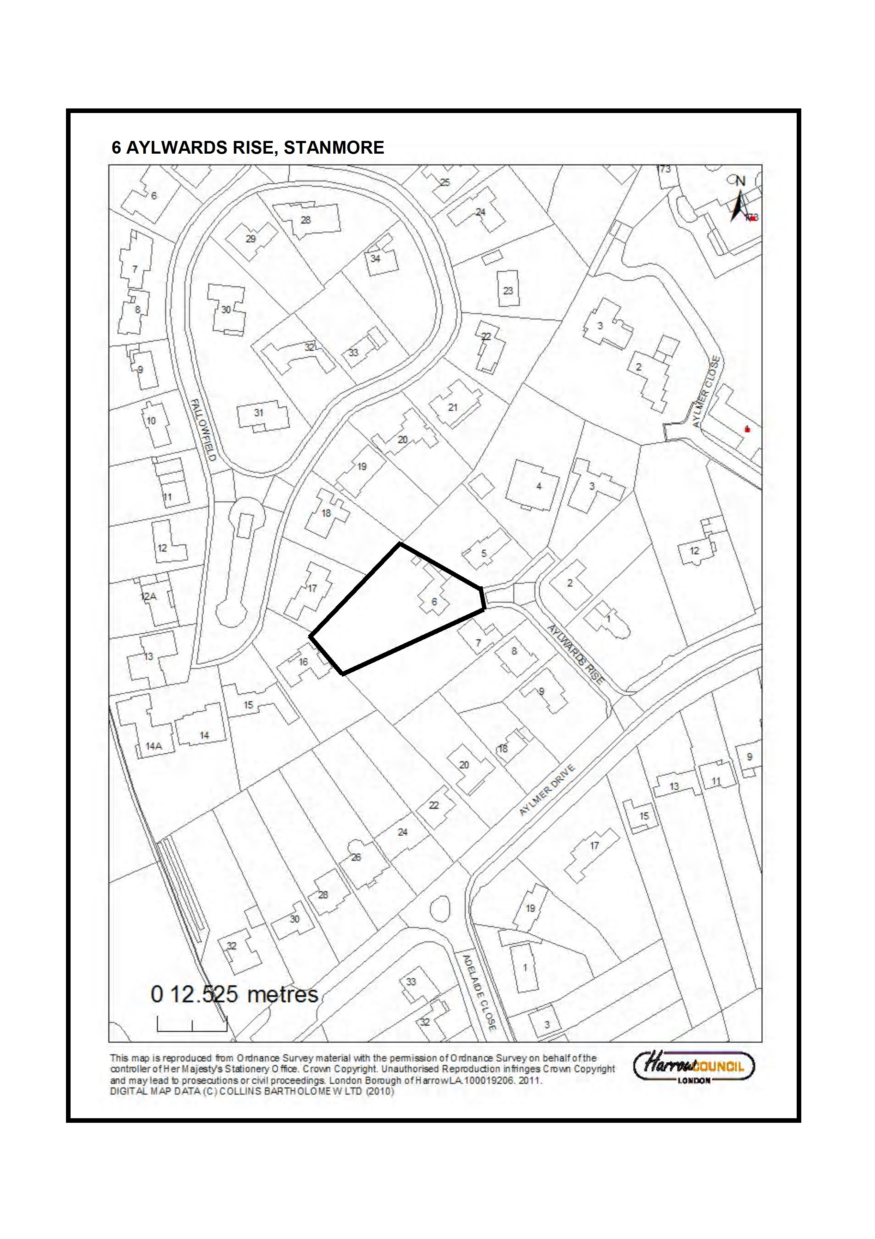
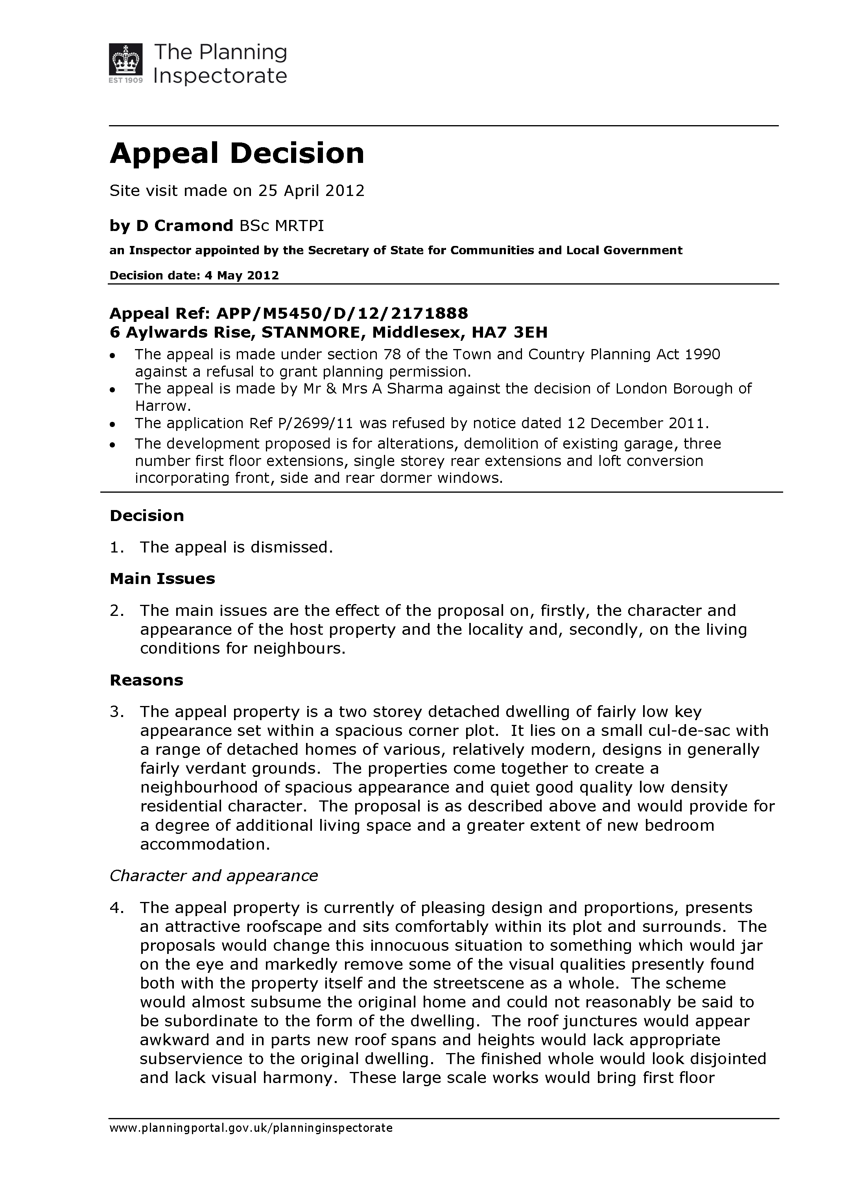
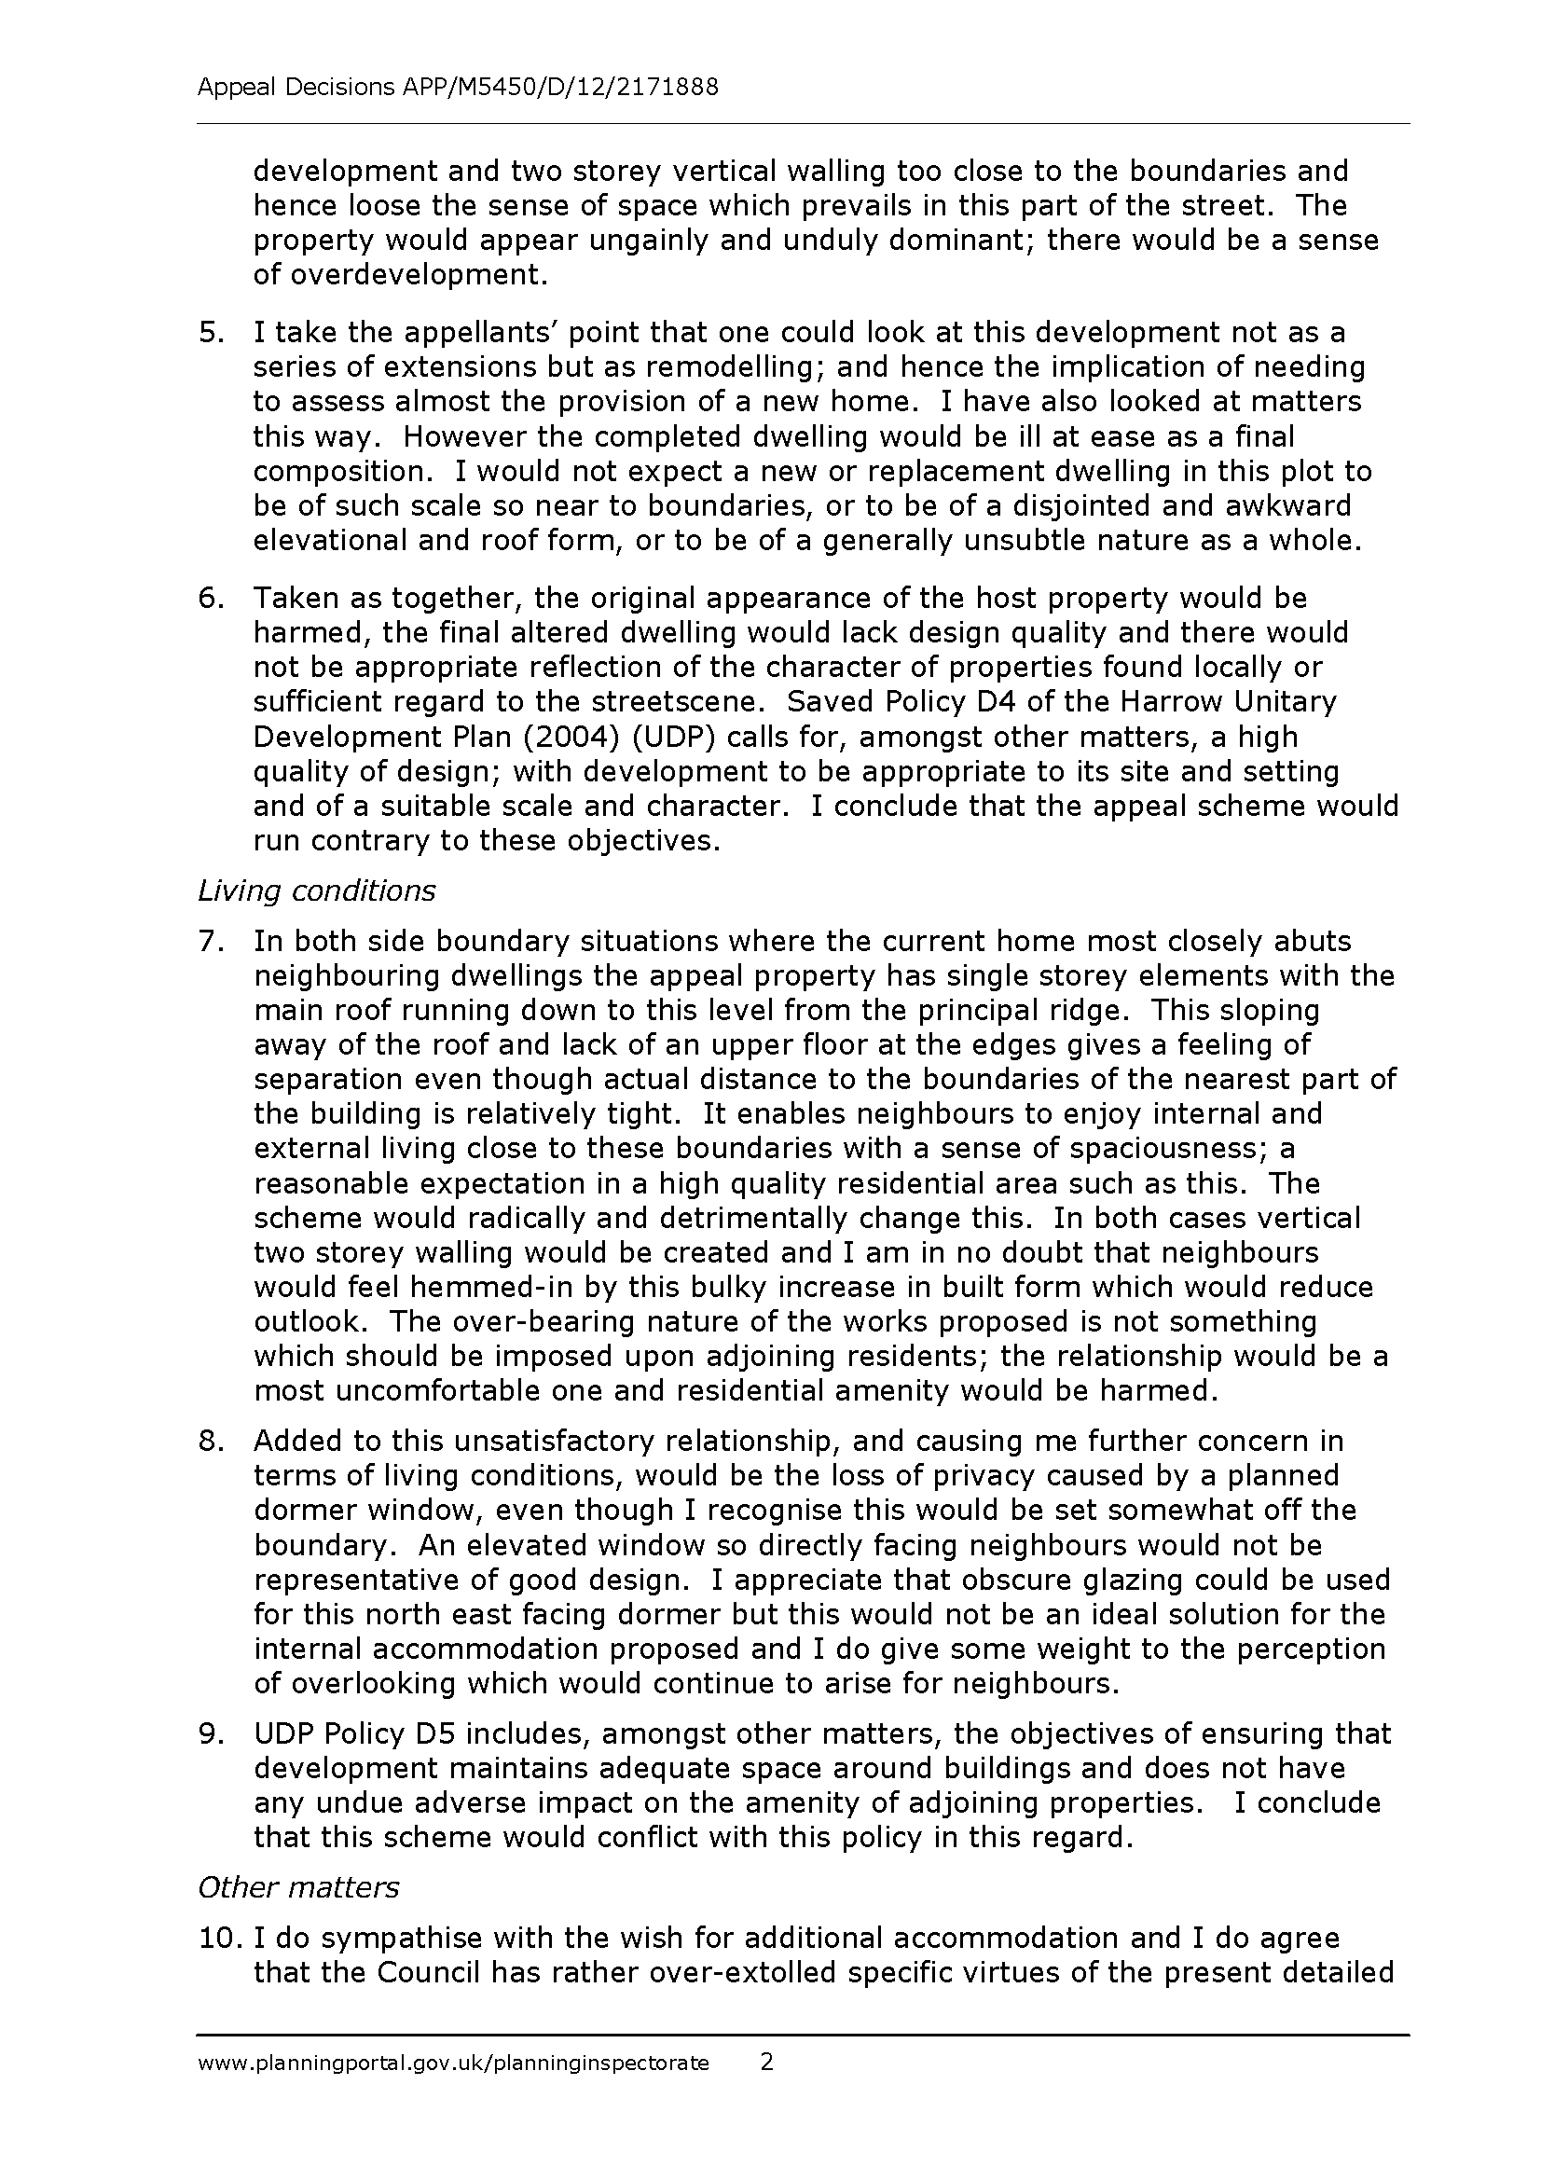
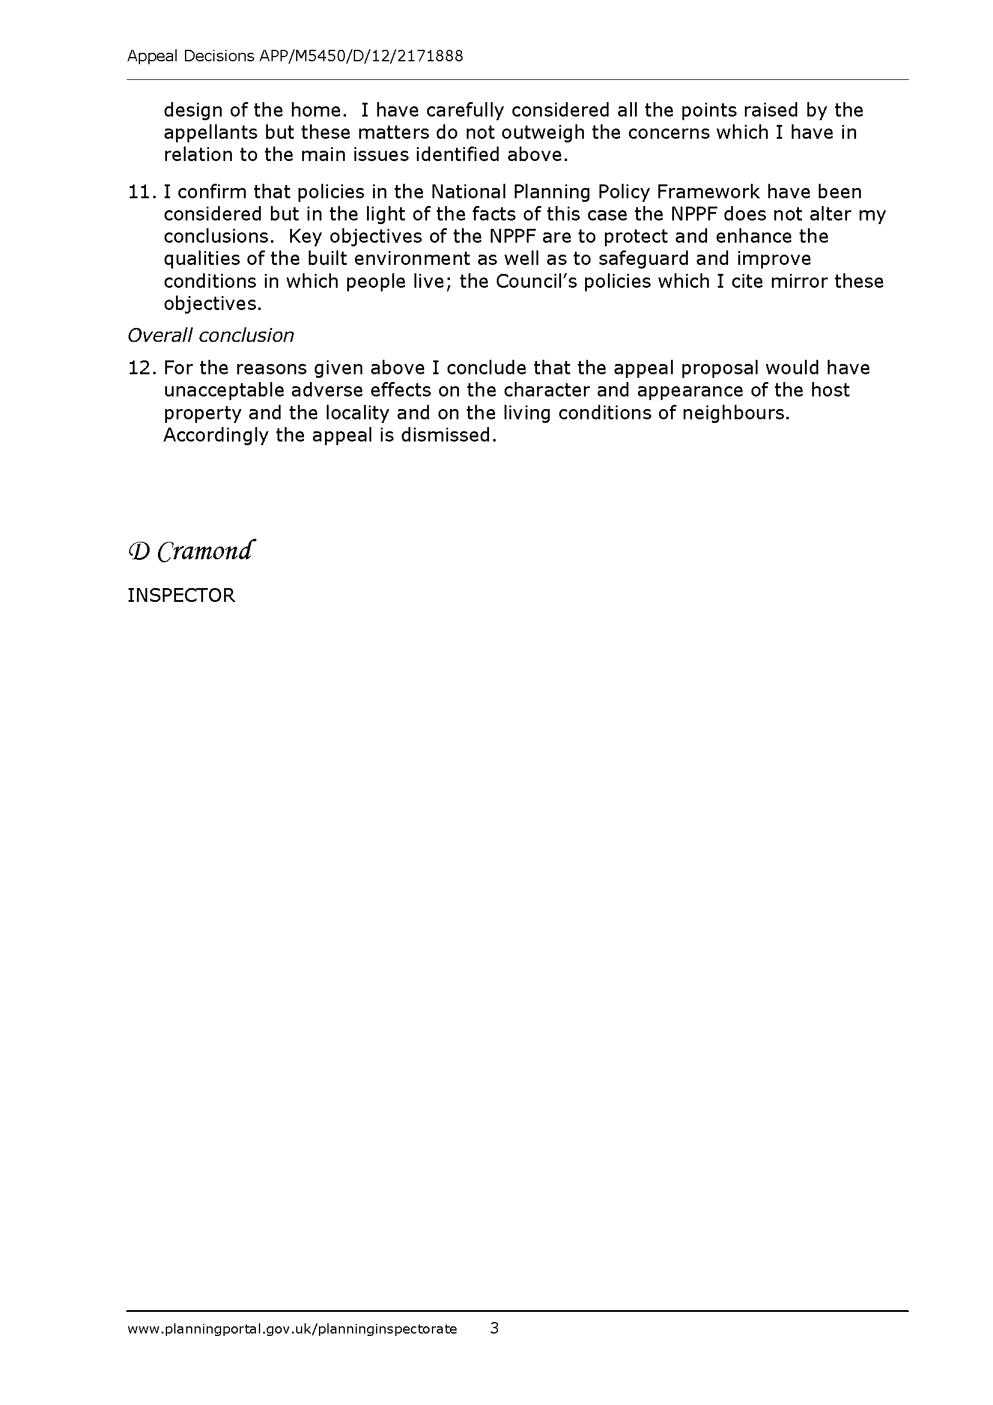
SECTION 4 - CONSULTATIONS FROM NEIGHBOURING AUTHORITIES

None.

SECTION 5 - PRIOR APPROVAL APPLICATIONS

None.

